**Data Analyst in Power BI Data-Camp 2025**

**Section 15: Reports Design in Power BI**

**Progressive Disclosure**

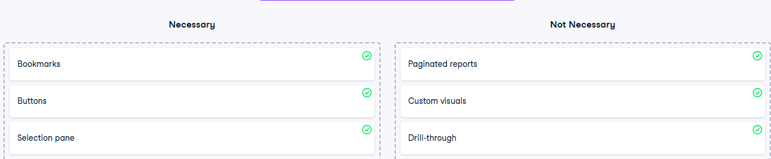

**Exercise 1.1** 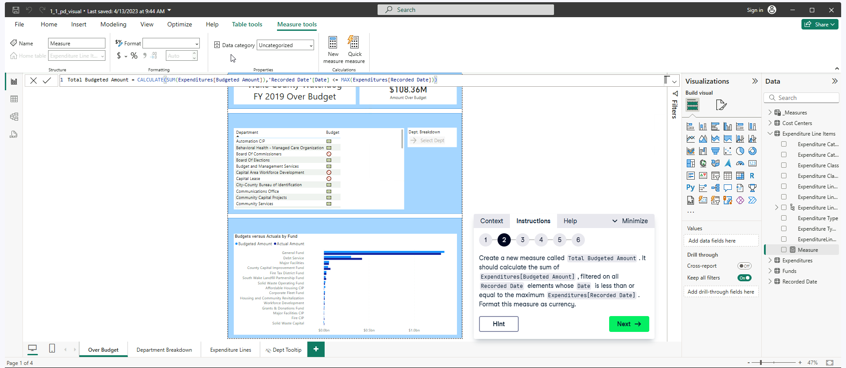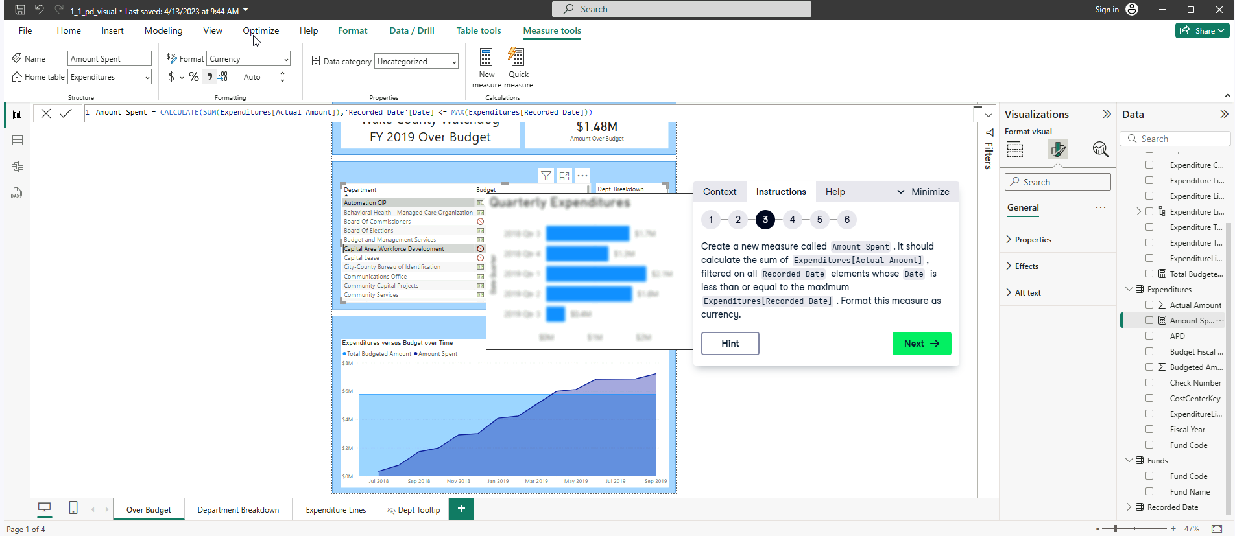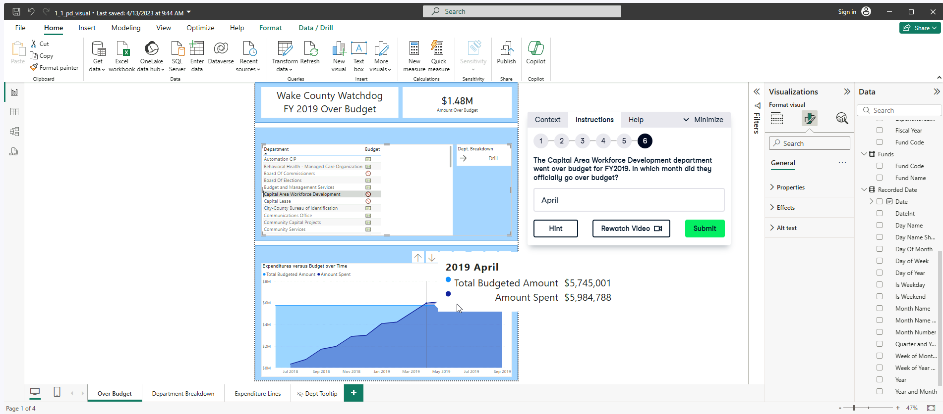

**Exercise 1.2**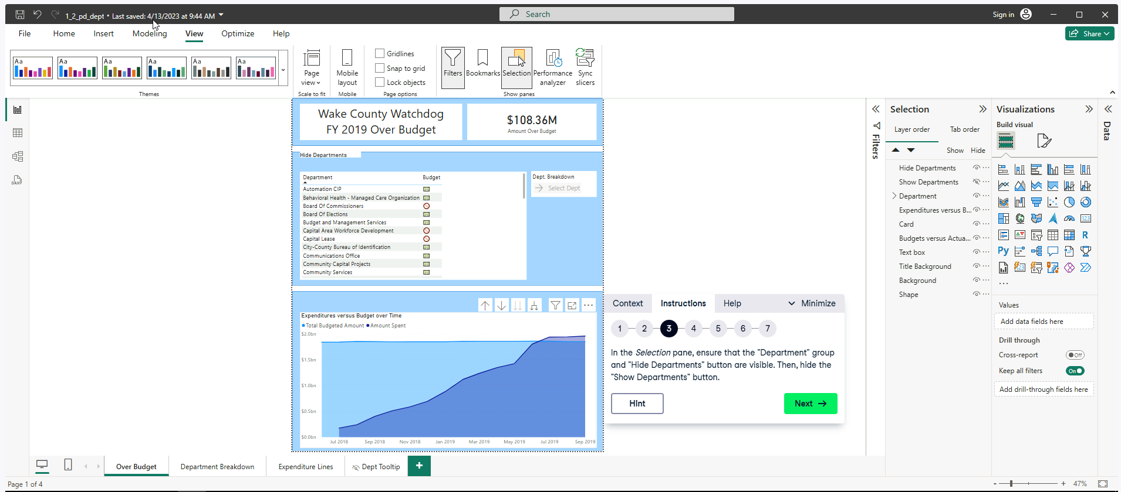

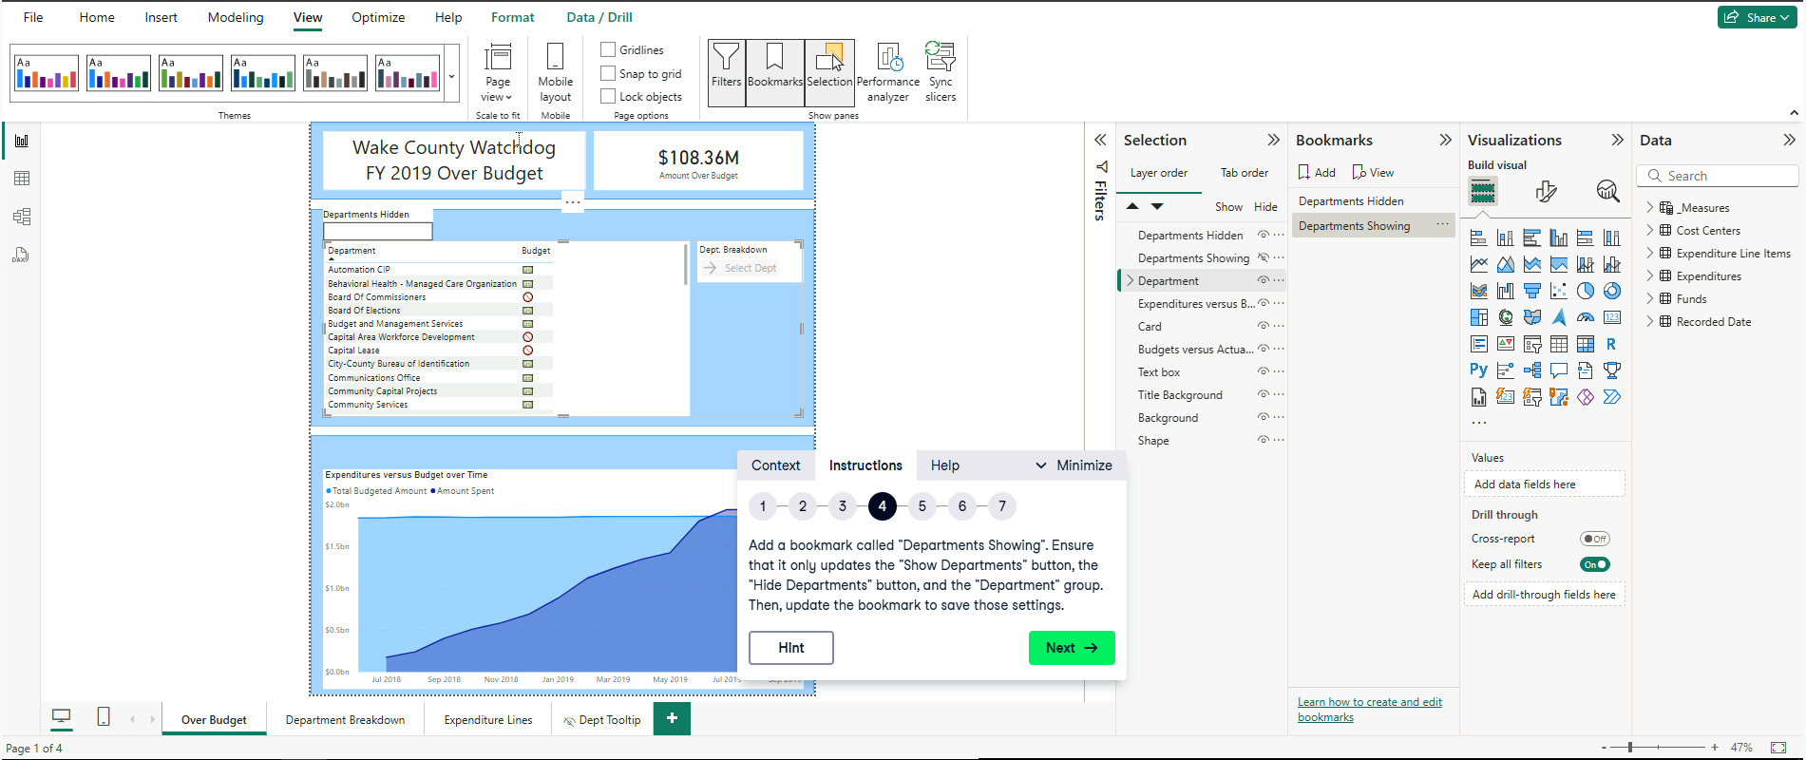Go to View tab, then select Selection pane then hide the “Hide Department” button. 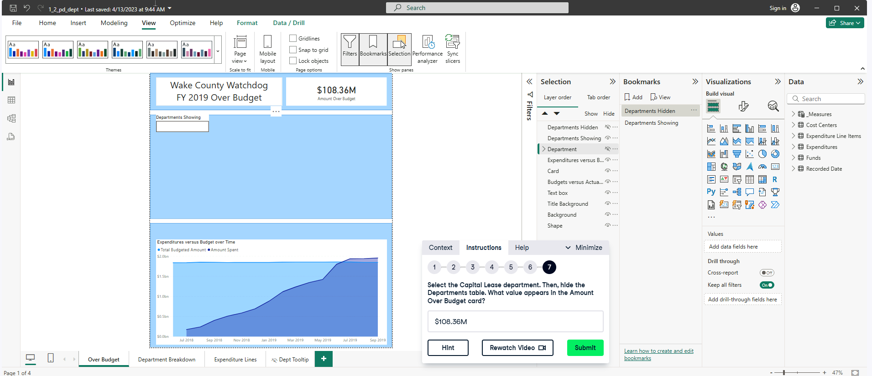 For Step 4. Before adding the “Departments Showing”, Hide Department Showing Button. Then Select (control and click) “Departments Hidden”, “Departments Showing” and “Department”. Select … Selected visuals then Update.

For Step 5. Before adding the “Departments Hidden”, Hide “Department Hidden” Button and “Department”. Then Select (control and click) “Departments Hidden”, “Departments Showing” and “Department”. Select … Selected visuals then Update.

For Step 6. Add actions for the “Hide Departments” and “Show Departments” button. Select Bookmark and attach the corresponding bookmark for each button.

Step 7. Select the Capital Lease Department. THEN HIDE THE DEPARTMENTS TABLE. THEN ANSWER THE FOLLOWING QUESTION. Answer shown below. 

**Exercise 1.3**

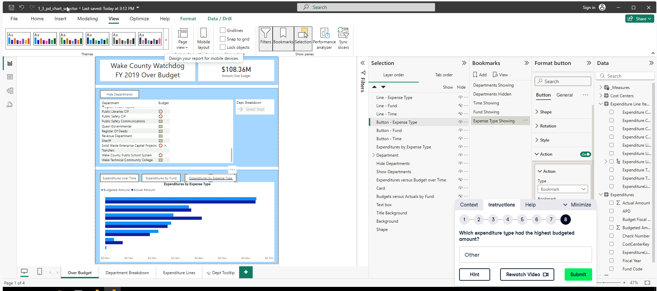

Step 7. Select the Capital Lease Department. THEN HIDE THE DEPARTMENTS TABLE. THEN ANSWER THE FOLLOWING QUESTION. Answer shown below.

Steps: In case you are ever self-doubt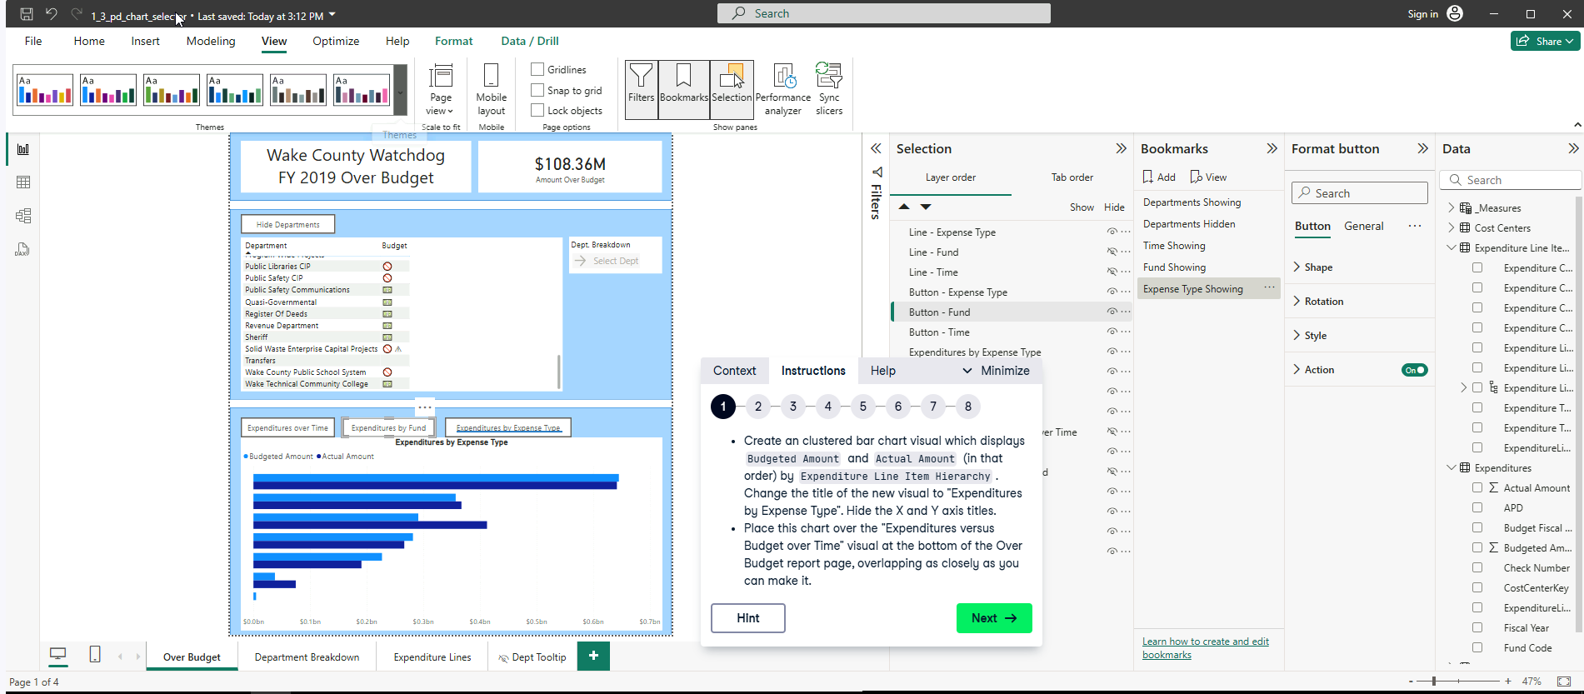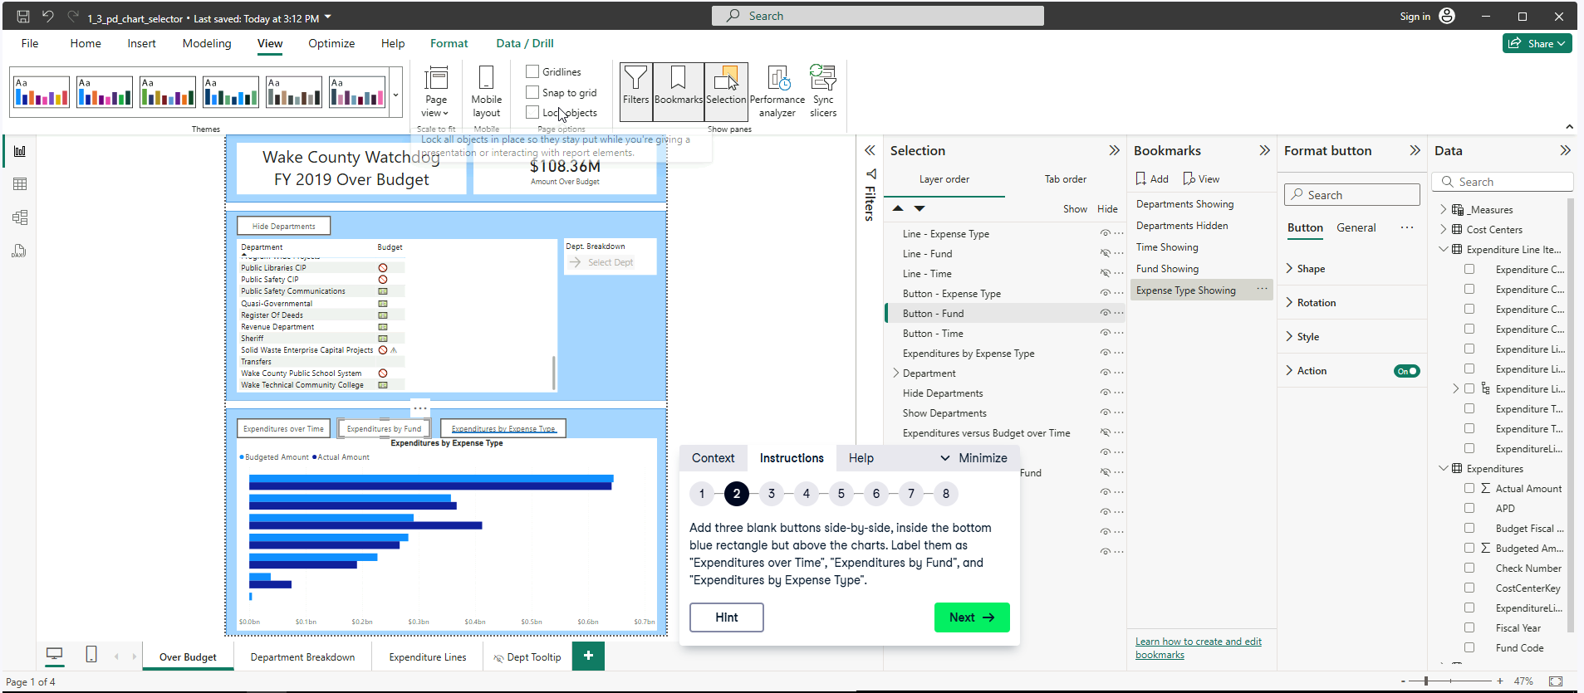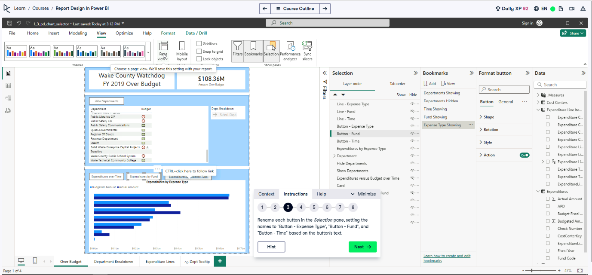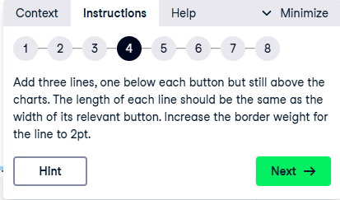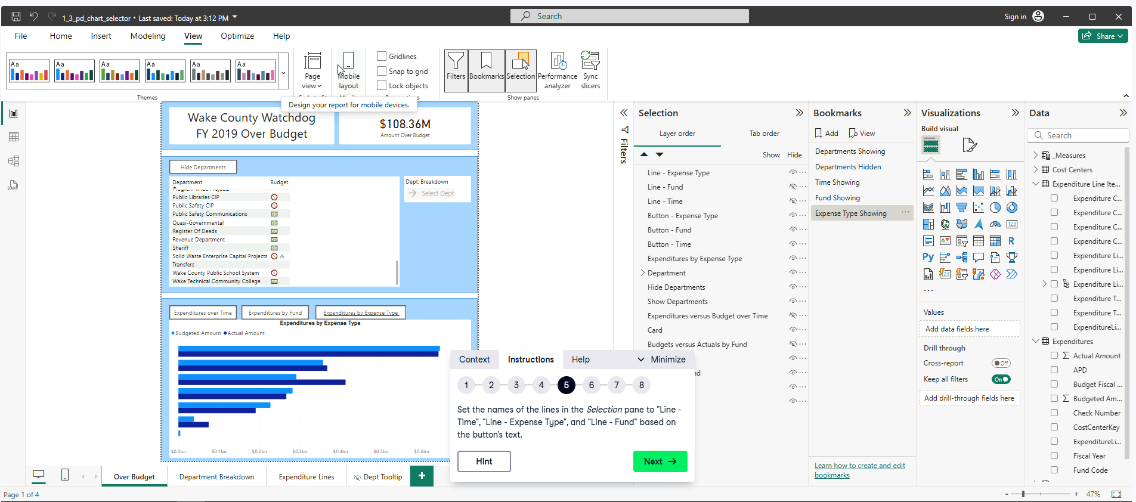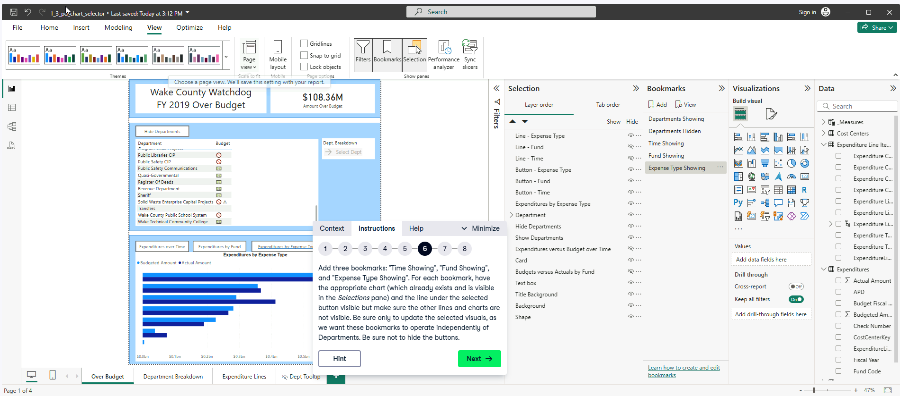

**For “Time Showing” bookmark,** before adding it: DO NOT HIDE THE BUTTONS. Hide Lines, “Line Expense Type”, “Line Fund” and Charts “Expenditures by Expense Type” and “Budgets versus Actuals by Funds”. THEN control select “Line – Expense Type”, “Line – Fund”, “Line – Time”, “Button – Expense Type”, “Button – Fund”, “Button – Time”, “Expenditures by Expense Type”, “Expenditures versus Budget over Time” and “Budgets versus Actuals by Fund”. Then go the “Time Showing” bookmark (…), click Selected visuals then (…) again to update them.

**For “Fund Showing” bookmark,** before adding it: DO NOT HIDE THE BUTTONS. Hide Lines, “Line Expense Type”, “Line Time” and Charts “Expenditures by Expense Type” and “Expenditures versus Budget over Time”. THEN control select “Line – Expense Type”, “Line – Fund”, “Line – Time”, “Button – Expense Type”, “Button – Fund”, “Button – Time”, “Expenditures by Expense Type”, “Expenditures versus Budget over Time” and “Budgets versus Actuals by Fund”. Then go the “Fund Showing” bookmark (…), click Selected visuals then (…) again to update them.

**For “Expense Type Showing” bookmark,** before adding it: DO NOT HIDE THE BUTTONS. Hide Lines, “Line Fund”, “Line Time” and Charts “Expenditures versus Budget over Time” and “Budgets versus Actuals by Fund”. THEN control select “Line – Expense Type”, “Line – Fund”, “Line – Time”, “Button – Expense Type”, “Button – Fund”, “Button – Time”, “Expenditures by Expense Type”, “Expenditures versus Budget over Time” and “Budgets versus Actuals by Fund”. Then go the “Time Showing” bookmark (…), click Selected visuals then (…) again to update them. 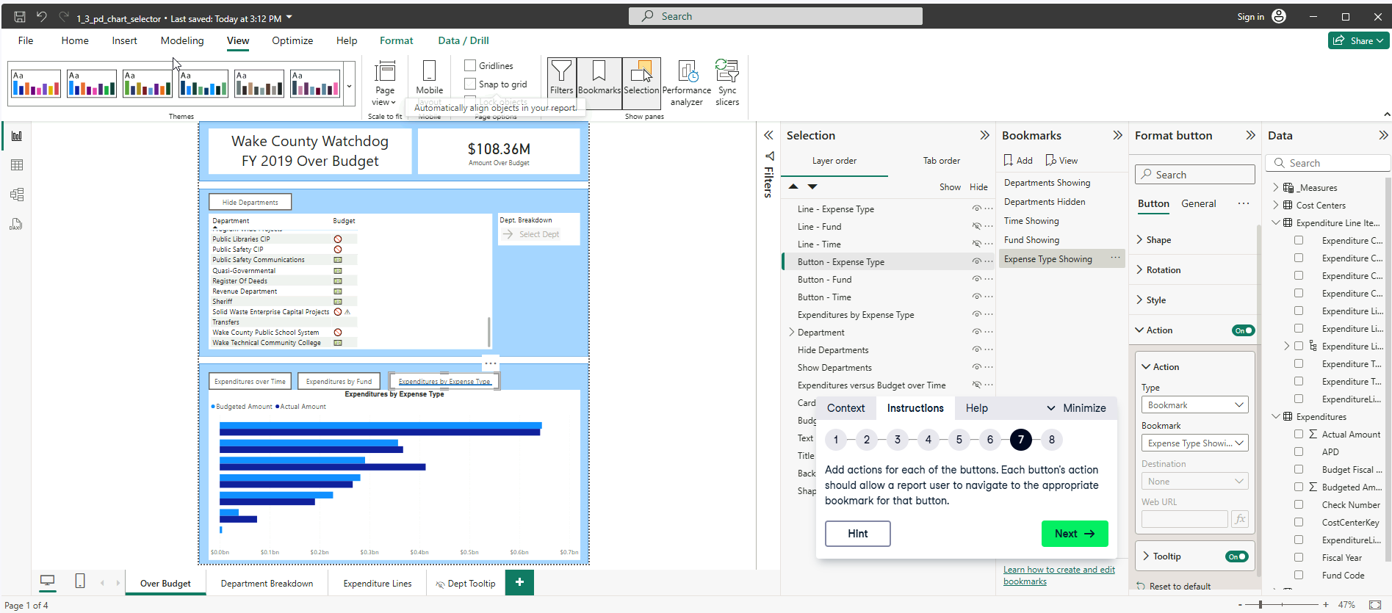

Select the button go to Action, then Type Bookmark and Bookmark MATCH TO THE CORRESPONDING BOOKMARK TO EACH BUTTON. (FOR EXAMPLE I SELECTED Button – Expense Type Showing then Attached with the bookmark “Expense Type Showing” shown above.)

**Customizing the View**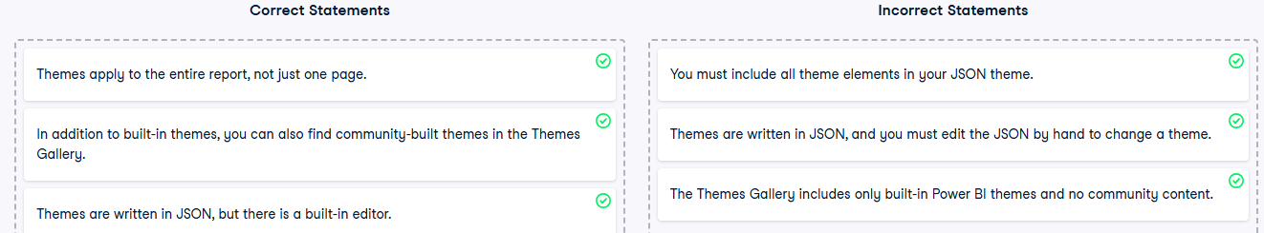

**Exercise 2.1**

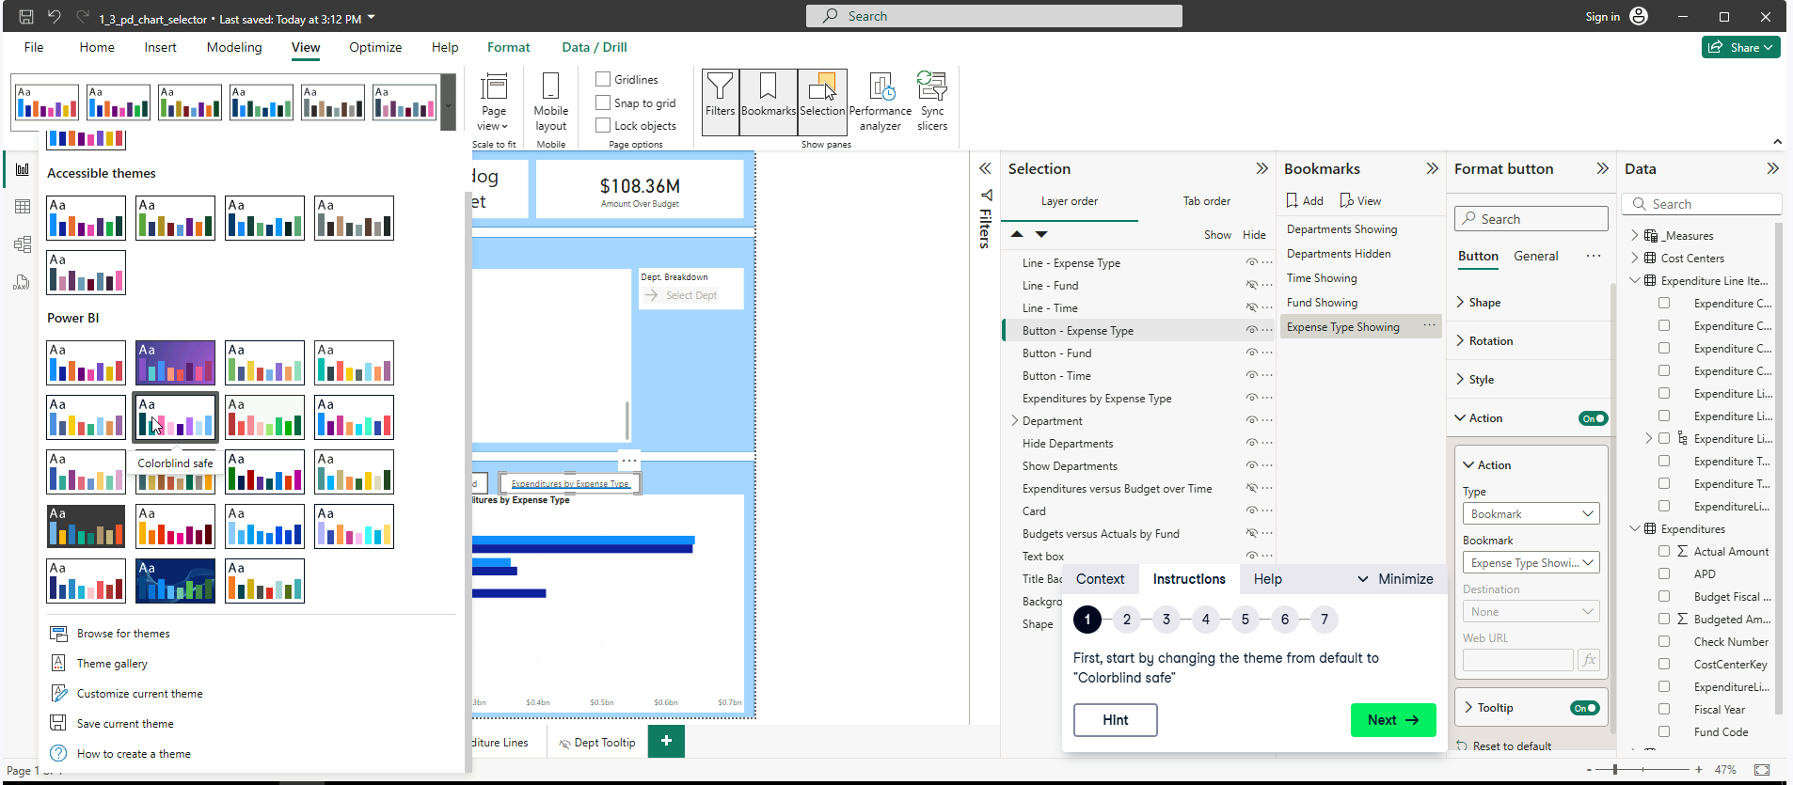

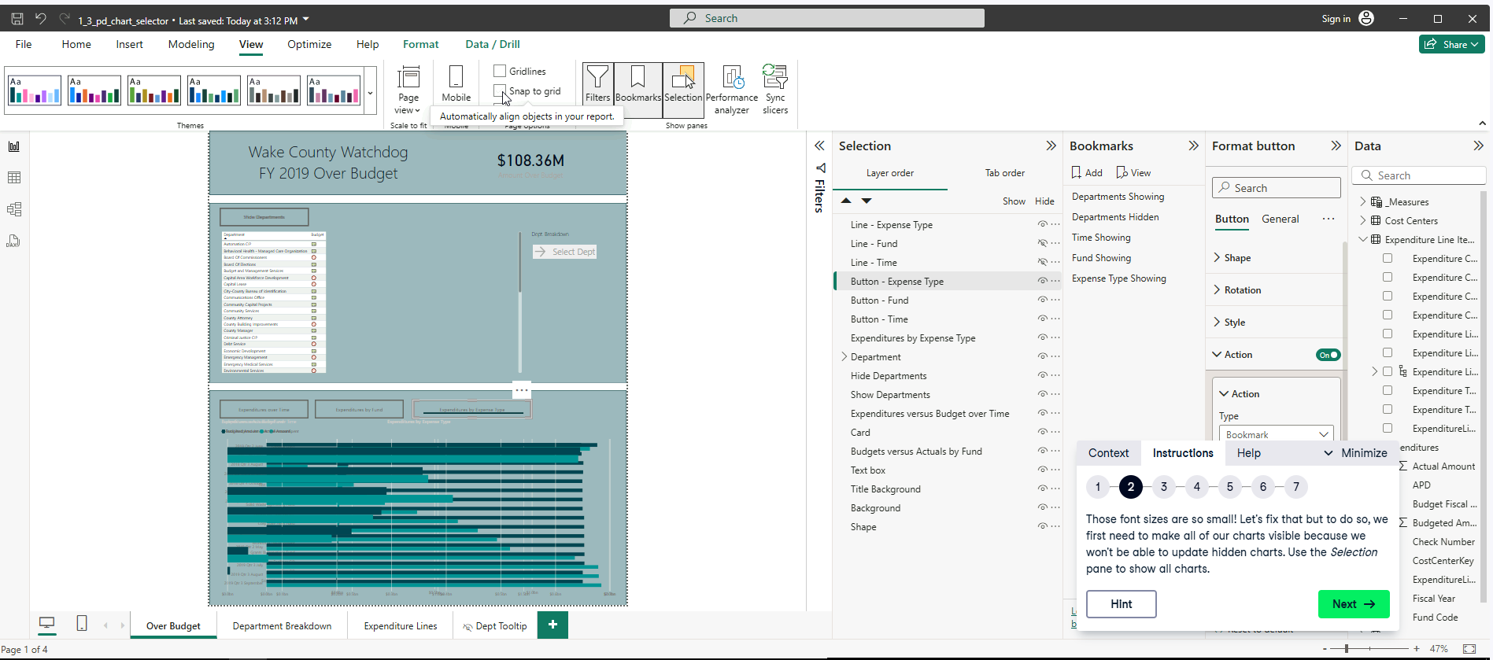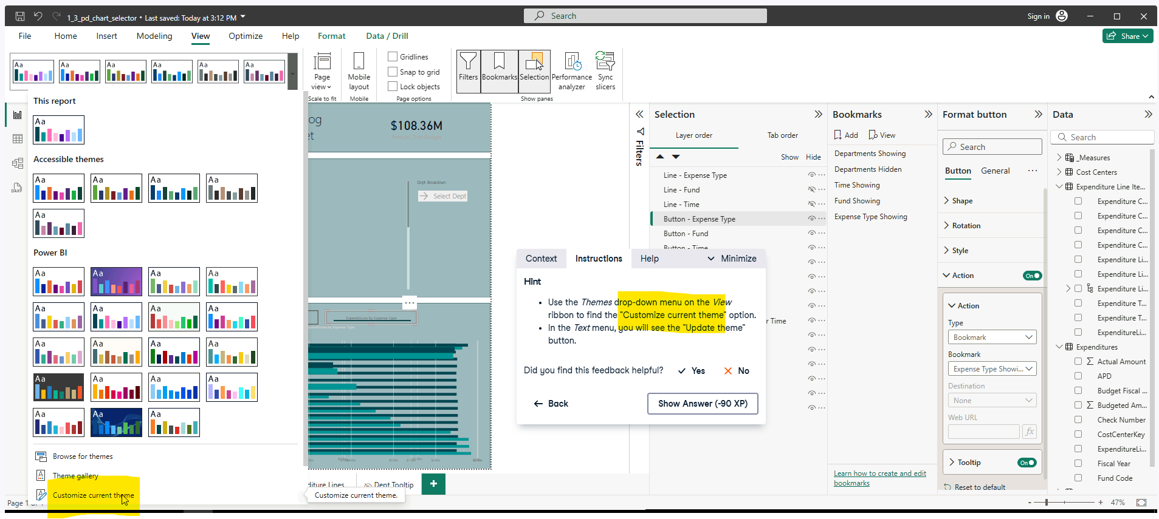

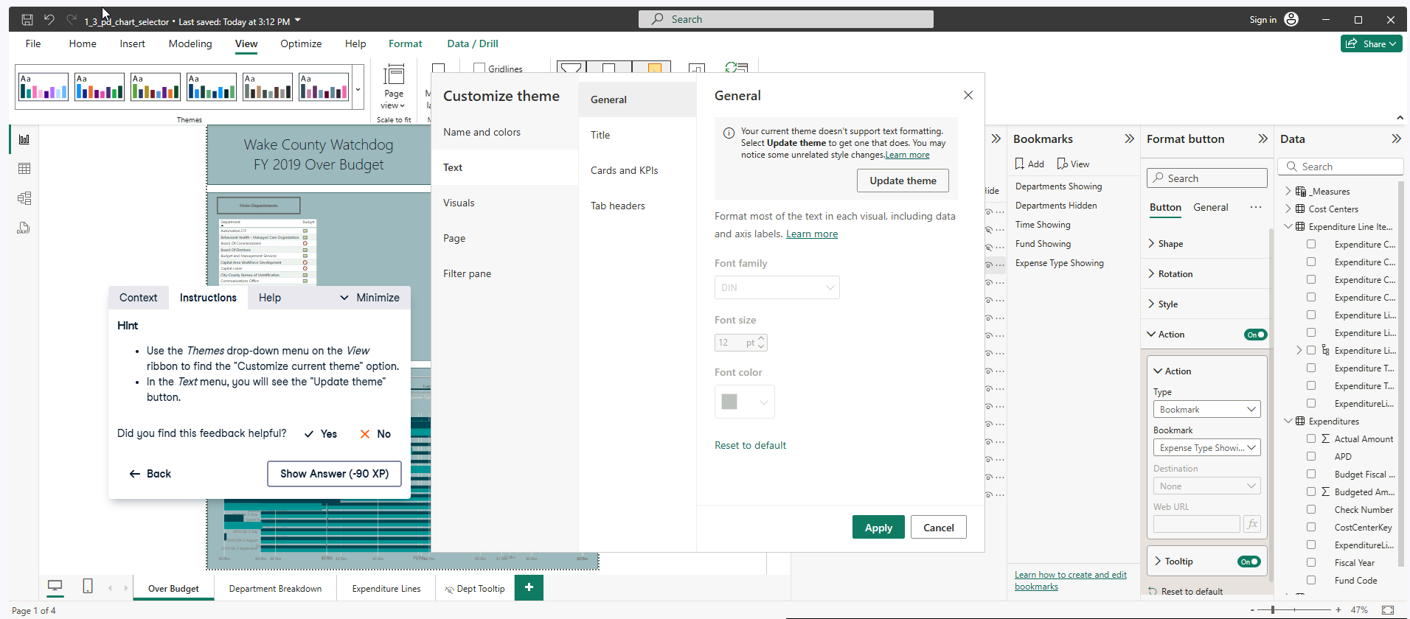

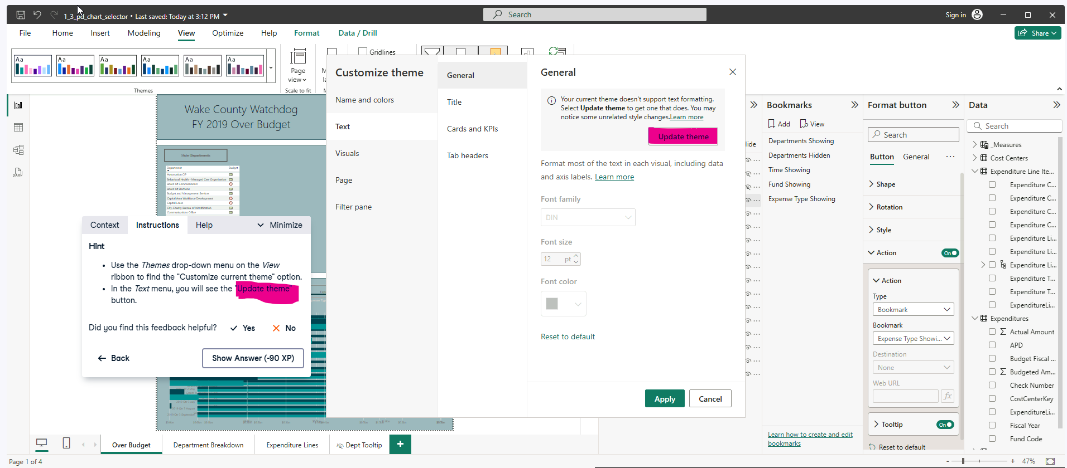

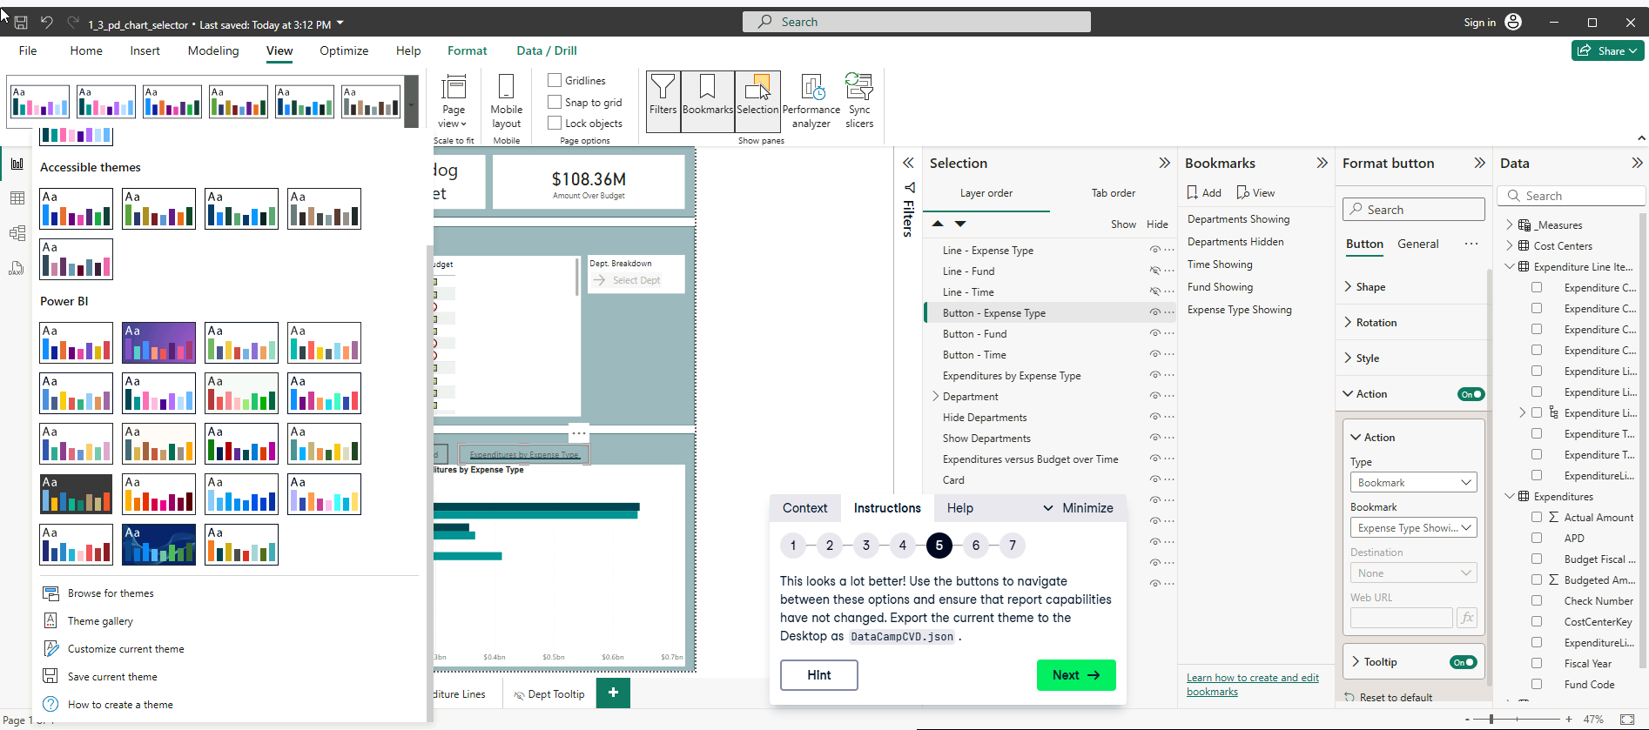

Export the JSON file, it should change the background theme.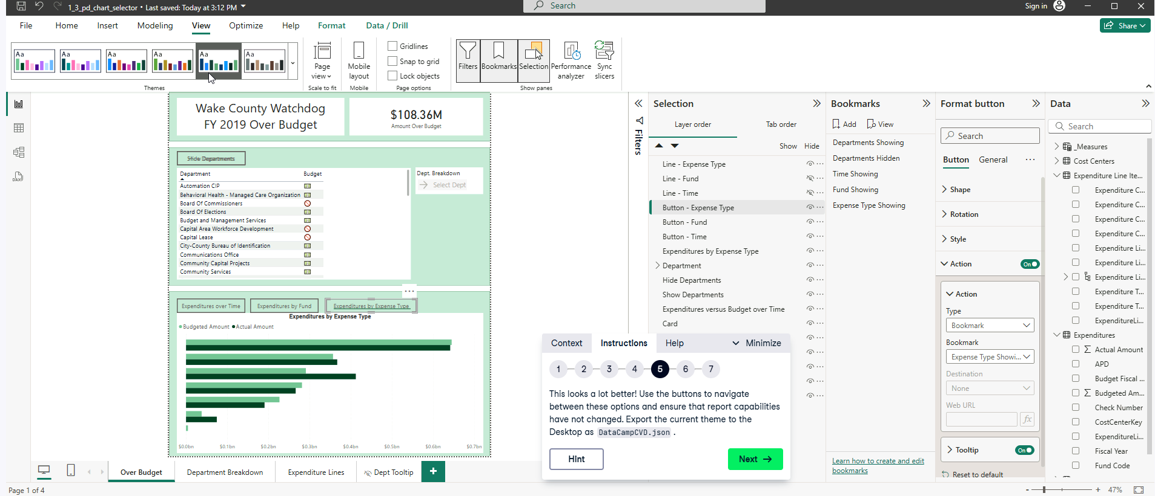

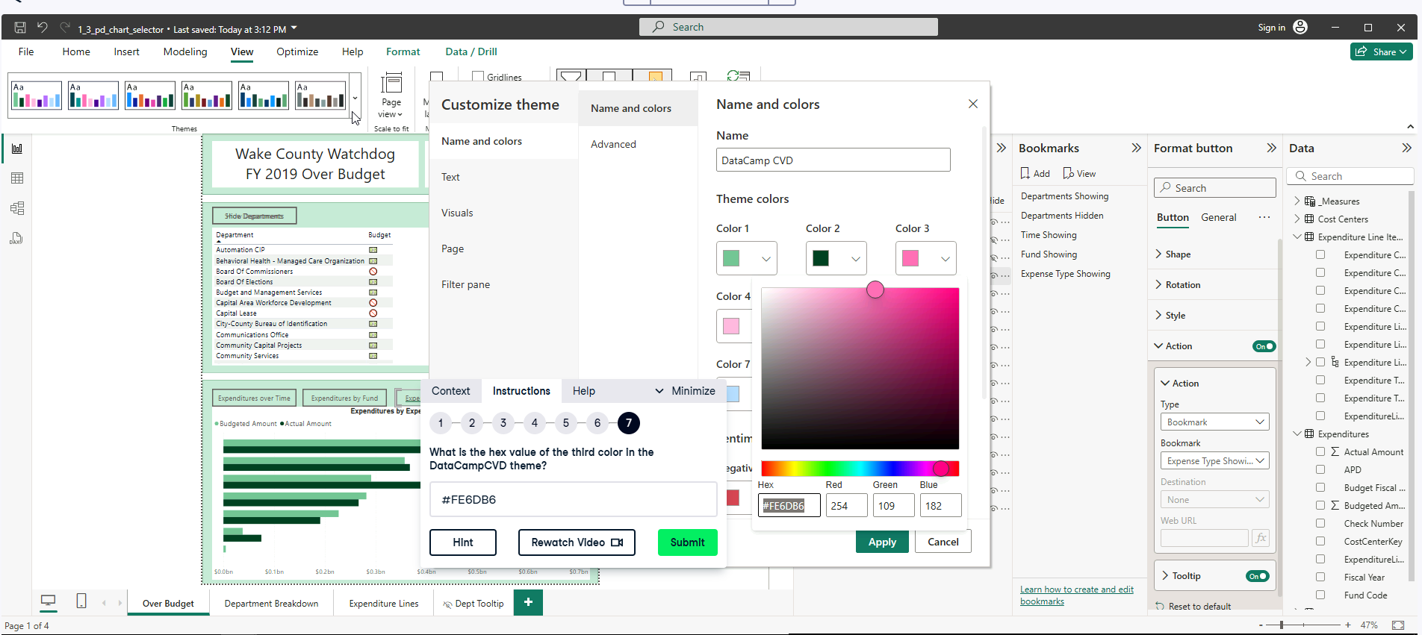

**Exercise 2.2**

To start go to View, (V) then select “Colorblind Safe” then Save the current theme then “Rename DataCamp CVD” then open the JSON in notepad. Then refer to Step 4.

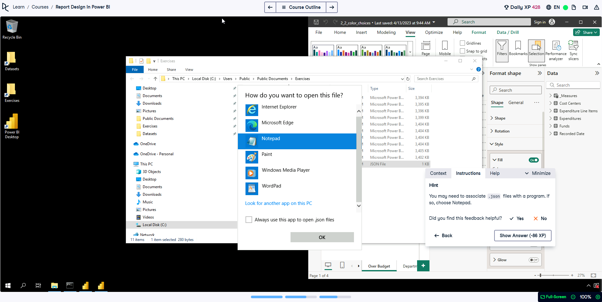

Step 4, after getting rid off the colors, keeping the first 8 colors. 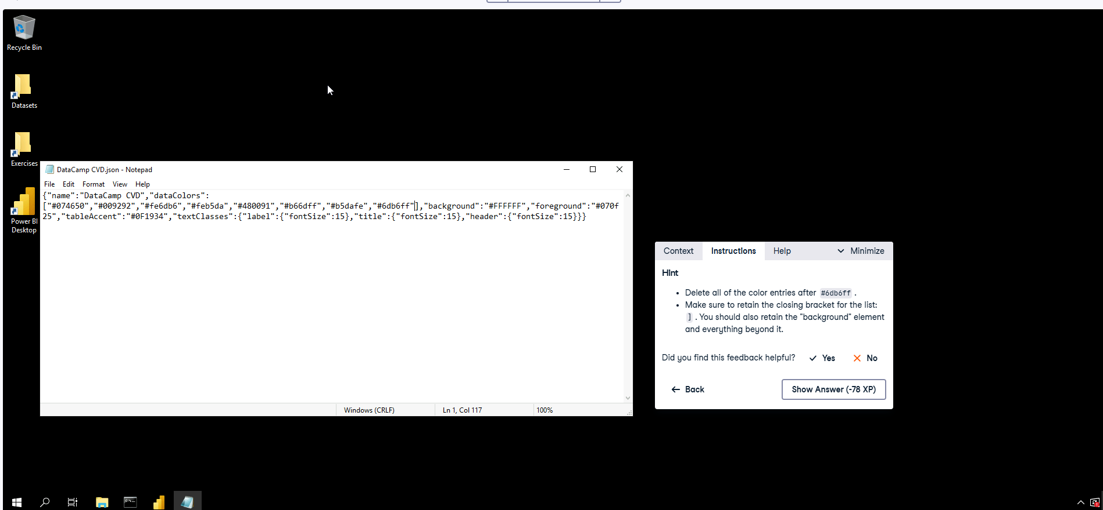

Step 5, replace the first two colors to “72c397” and “044127” respectively. 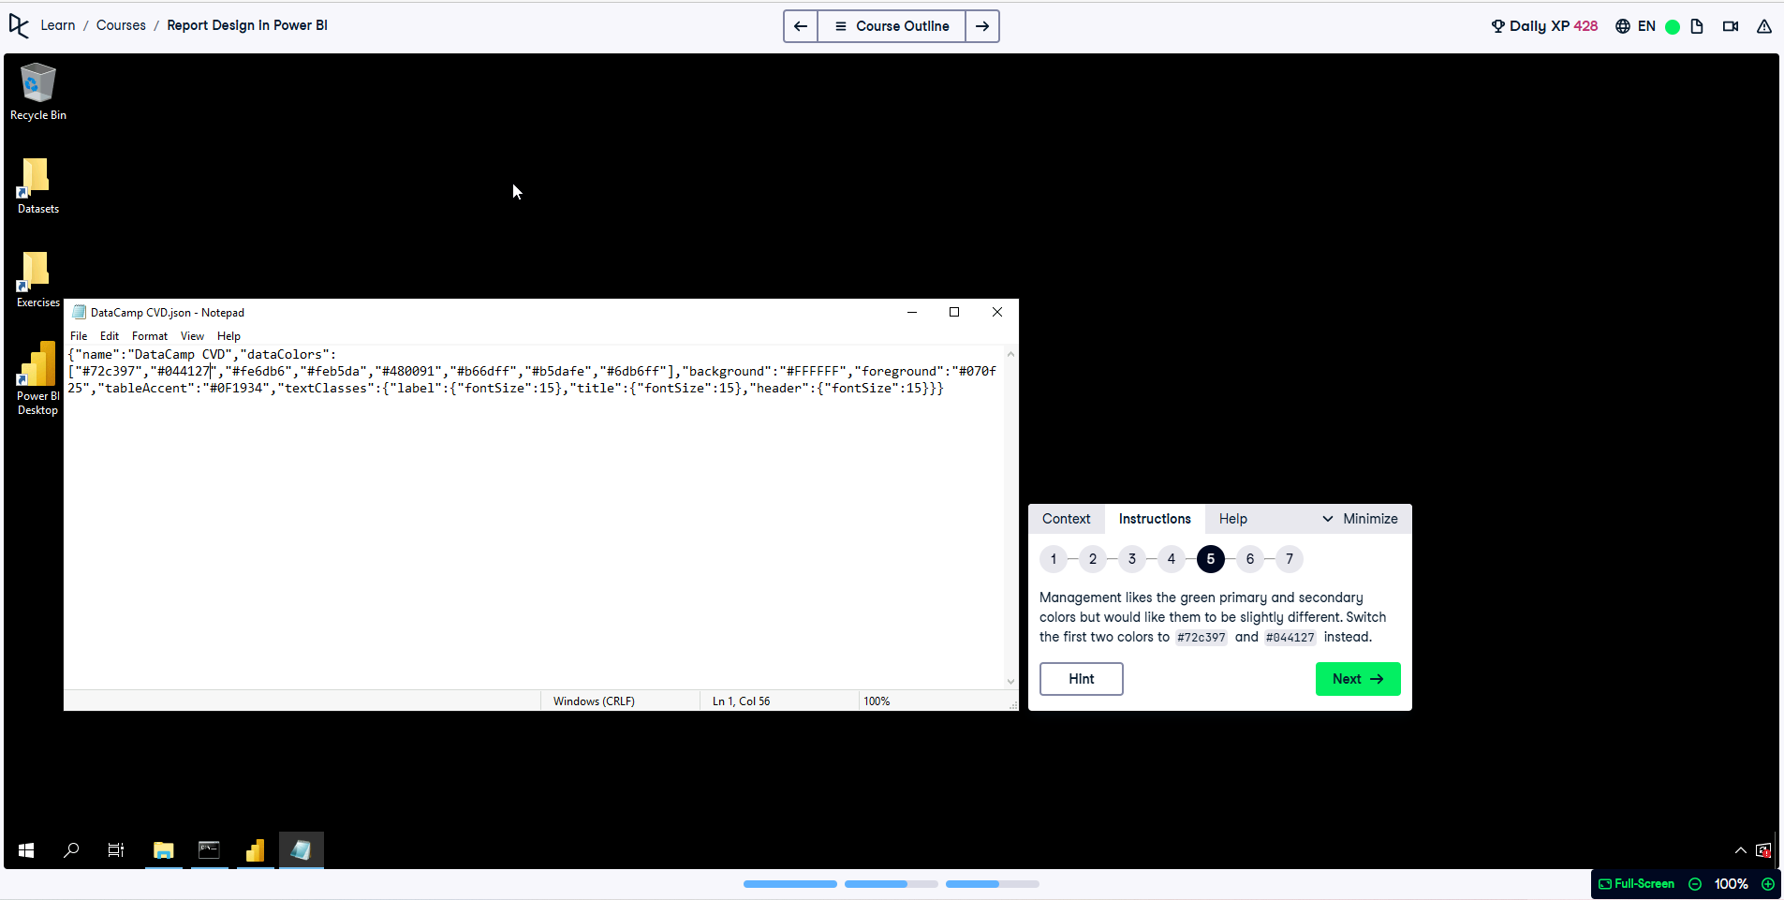

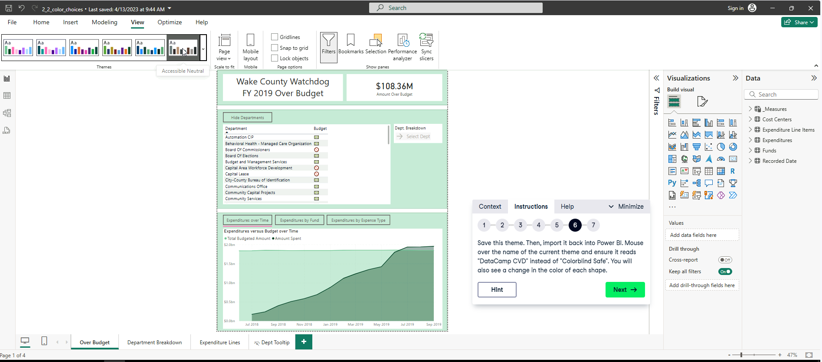

**Solution:**

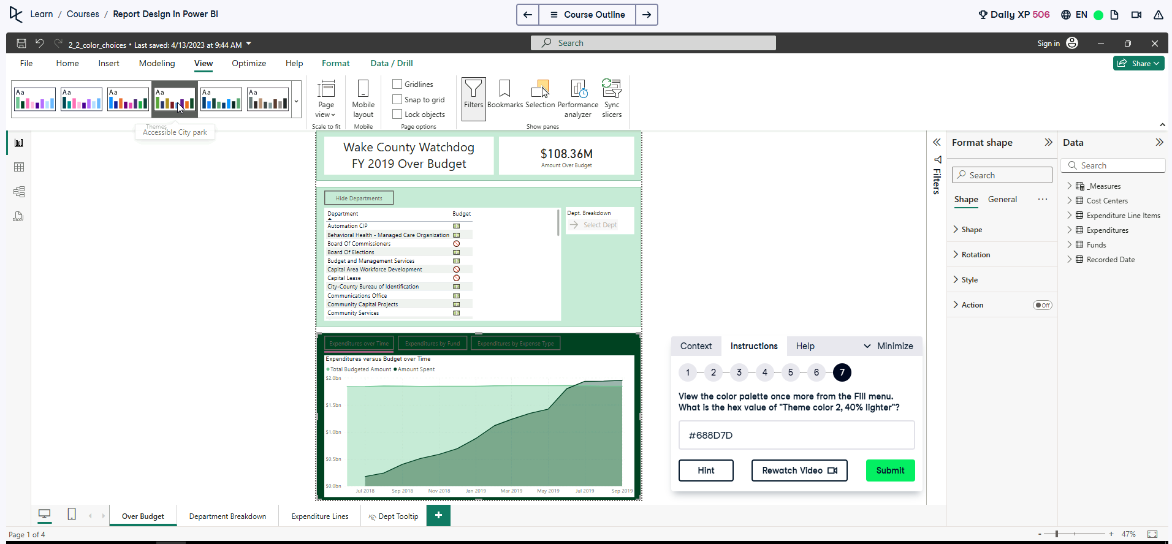

How? Go to View (v) on the themes. Then, go to Customize current theme view the Color 2 and Select the Hex value OR find the RGB values then Apply the Lightening Formula:

**🔹 Lighten a color by a percentage**

For each RGB channel (R, G, or B):

NewValue = OldValue + (255 − OldValue) × LightenPercentage

Where:

* **OldValue** = original R, G, or B value (0–255)
* **LightenPercentage** = 0.40 for 40% lighter
* R: 4 + (255 − 4) × 0.4 = 104
* G: 65 + (255 − 65) × 0.4 = 141
* B: 39 + (255 − 39) × 0.4 = 125

New RGB = (104, 141, 125) → HEX = #688D7D

**Exercise 2.3**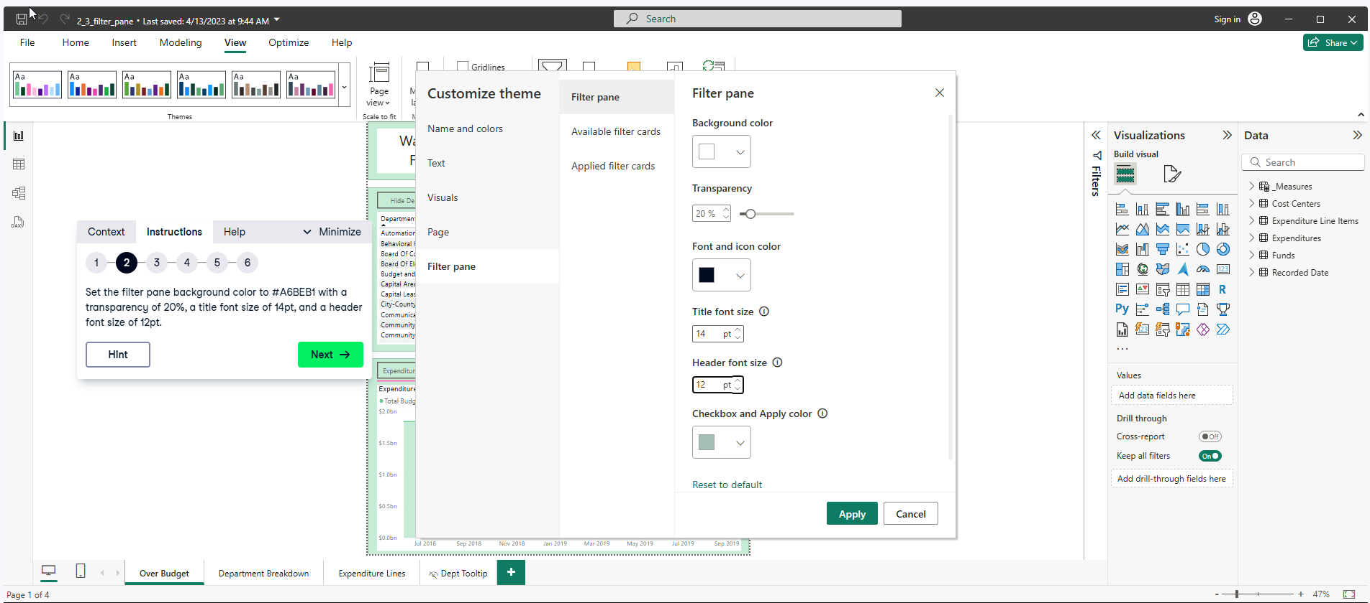

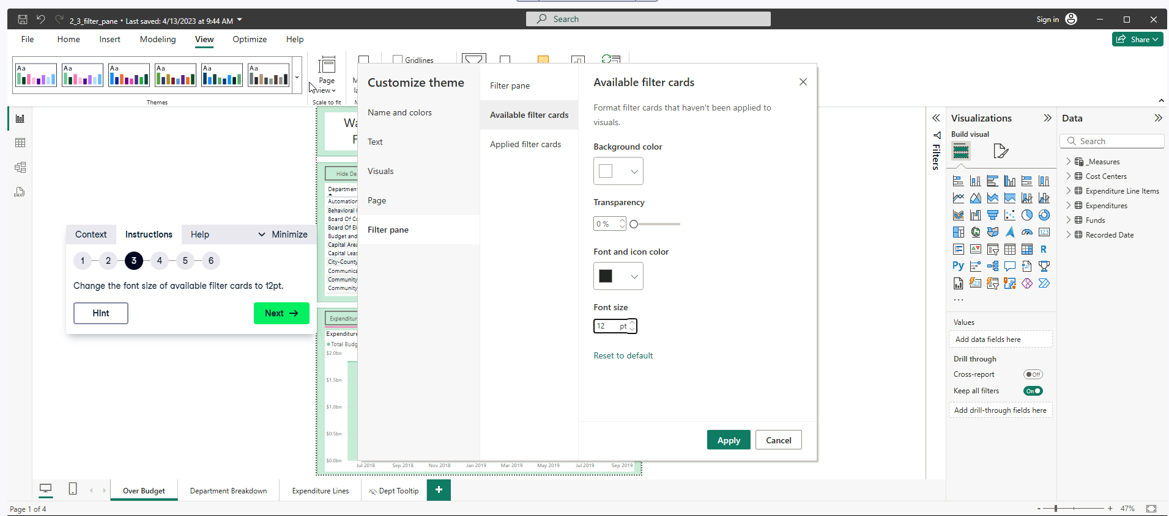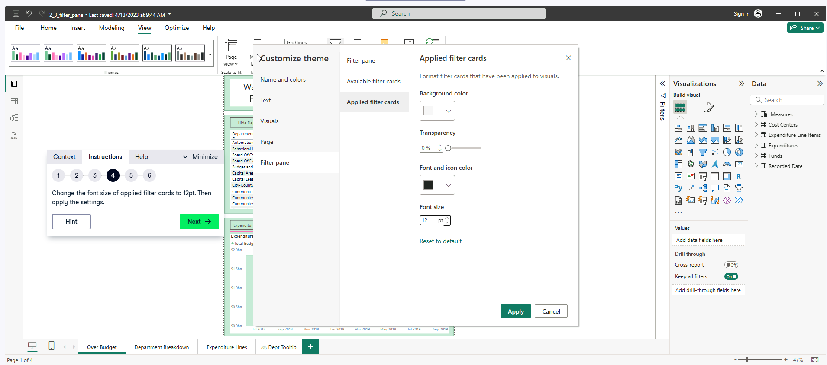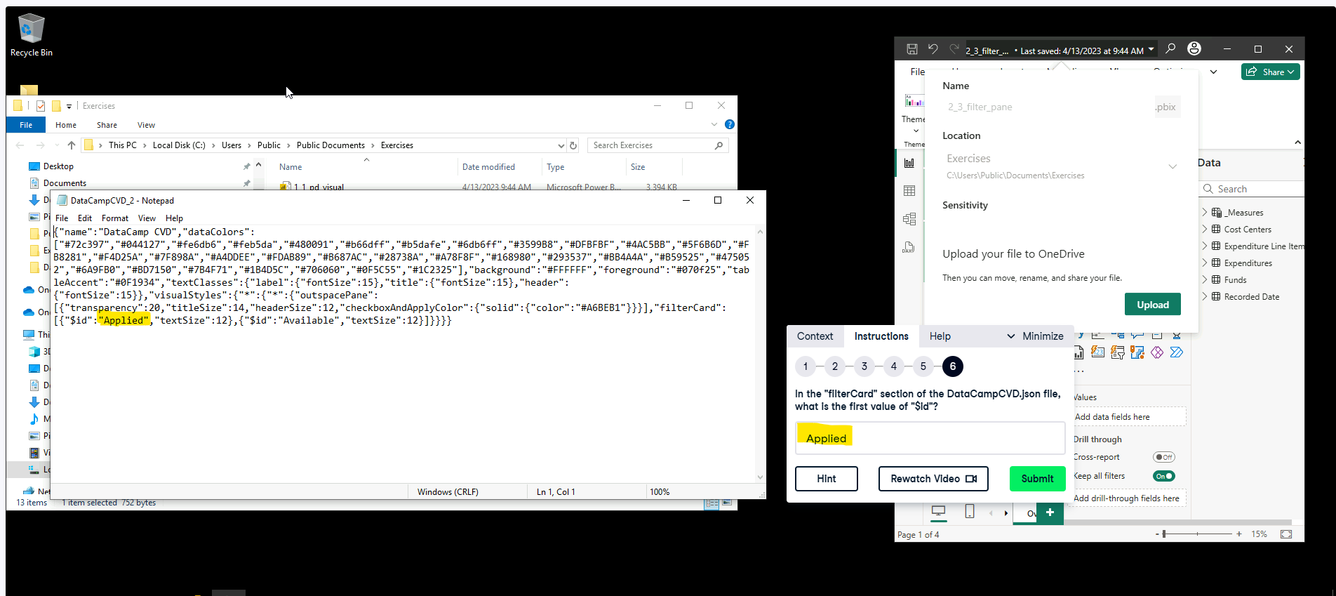

**Design for Mobile Devices** 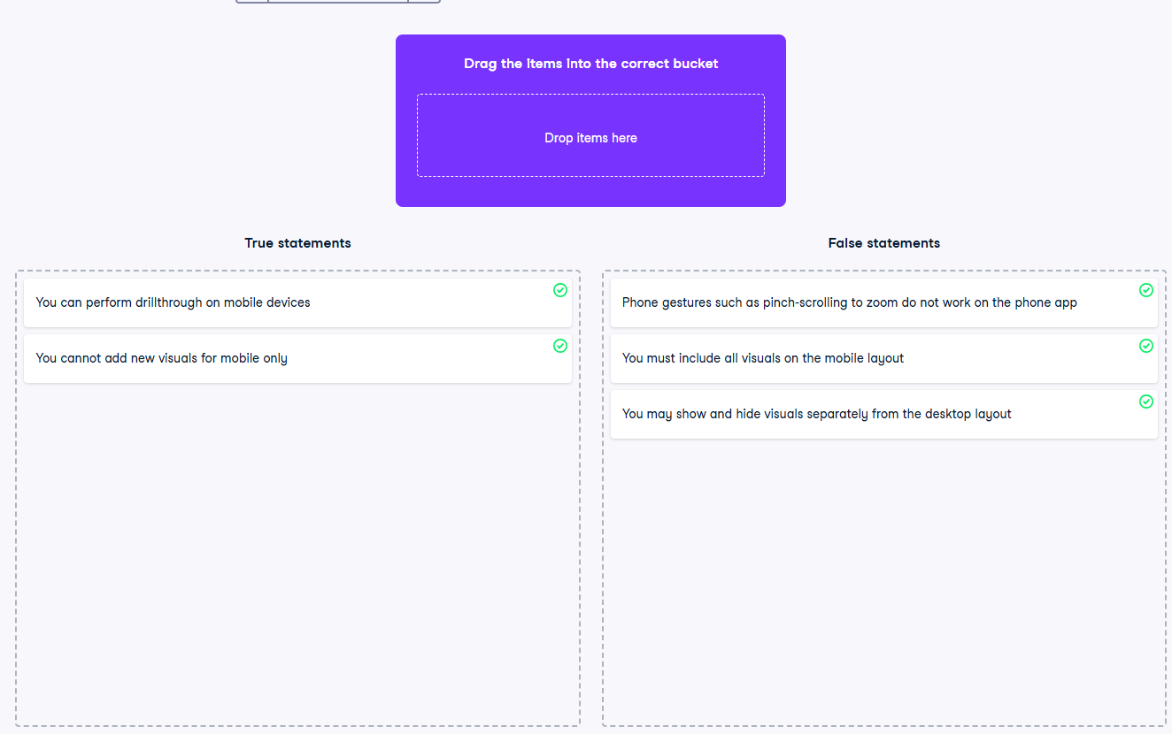

**Exercise 3.1** 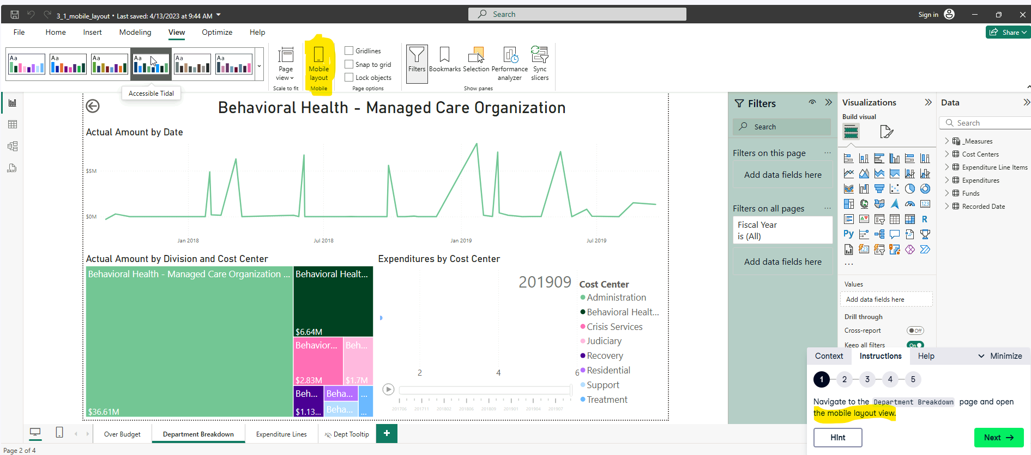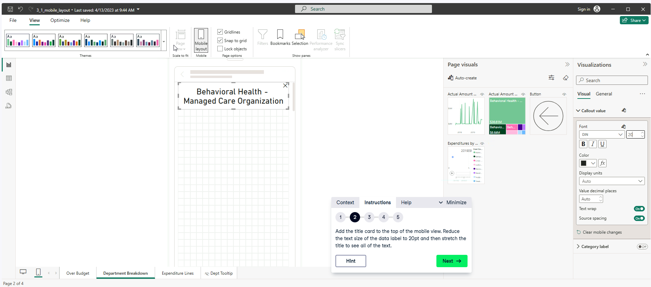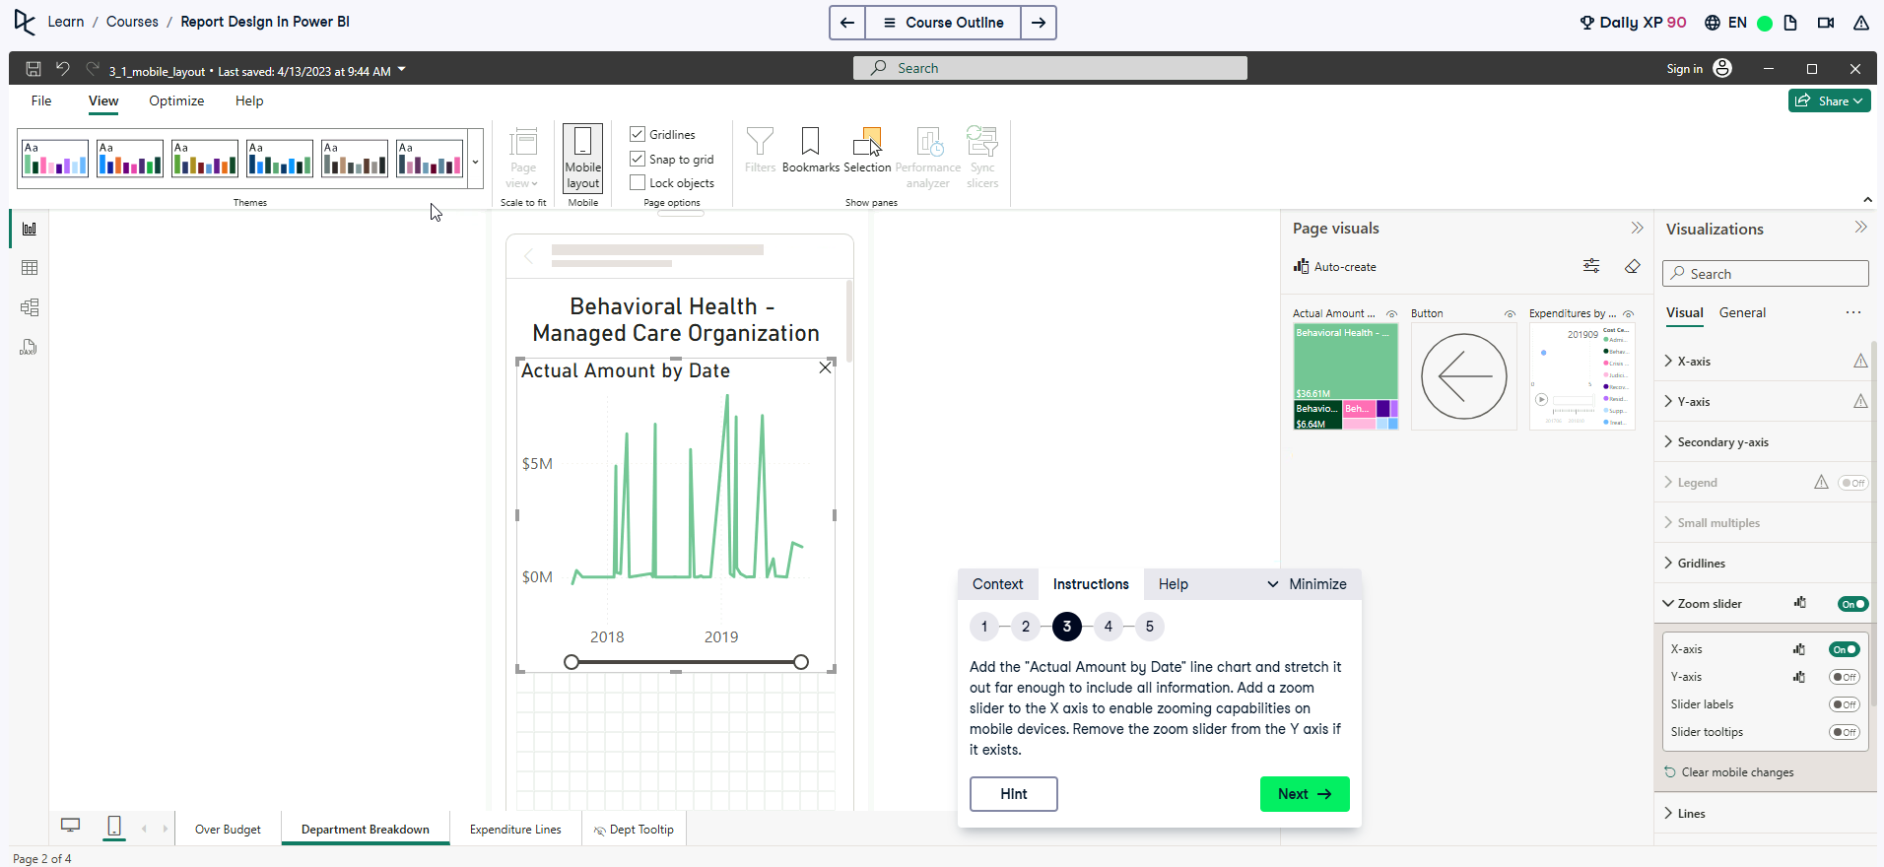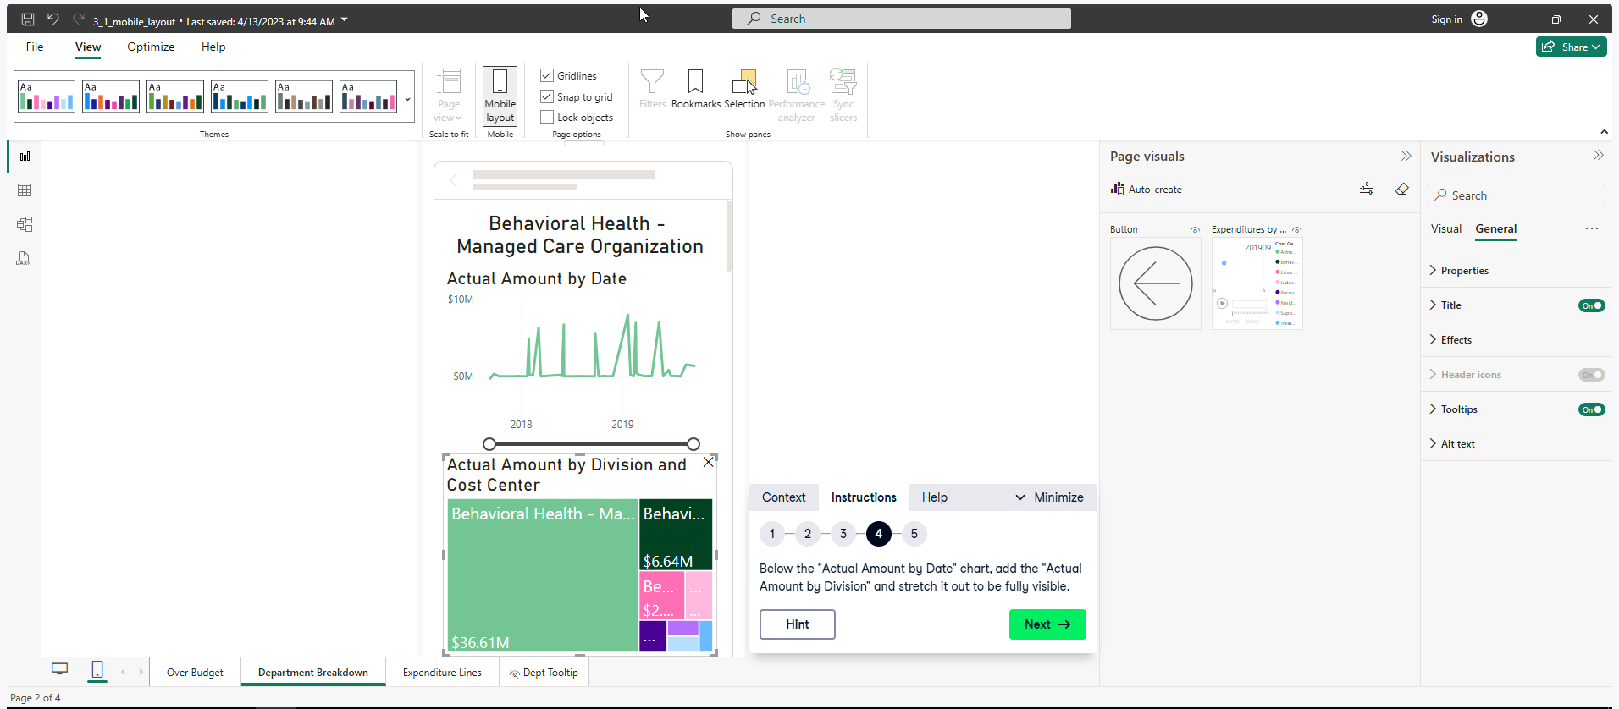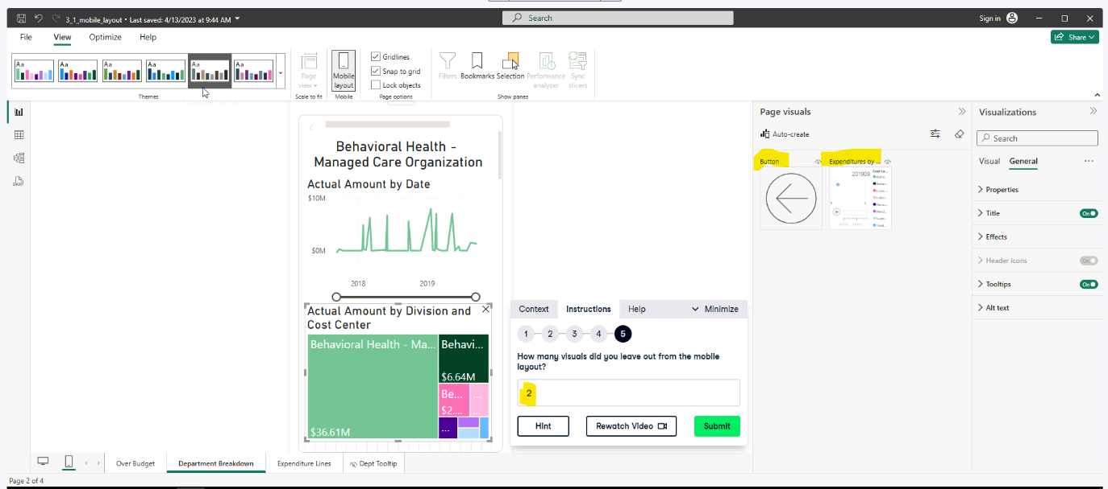

**Exercise 3.2**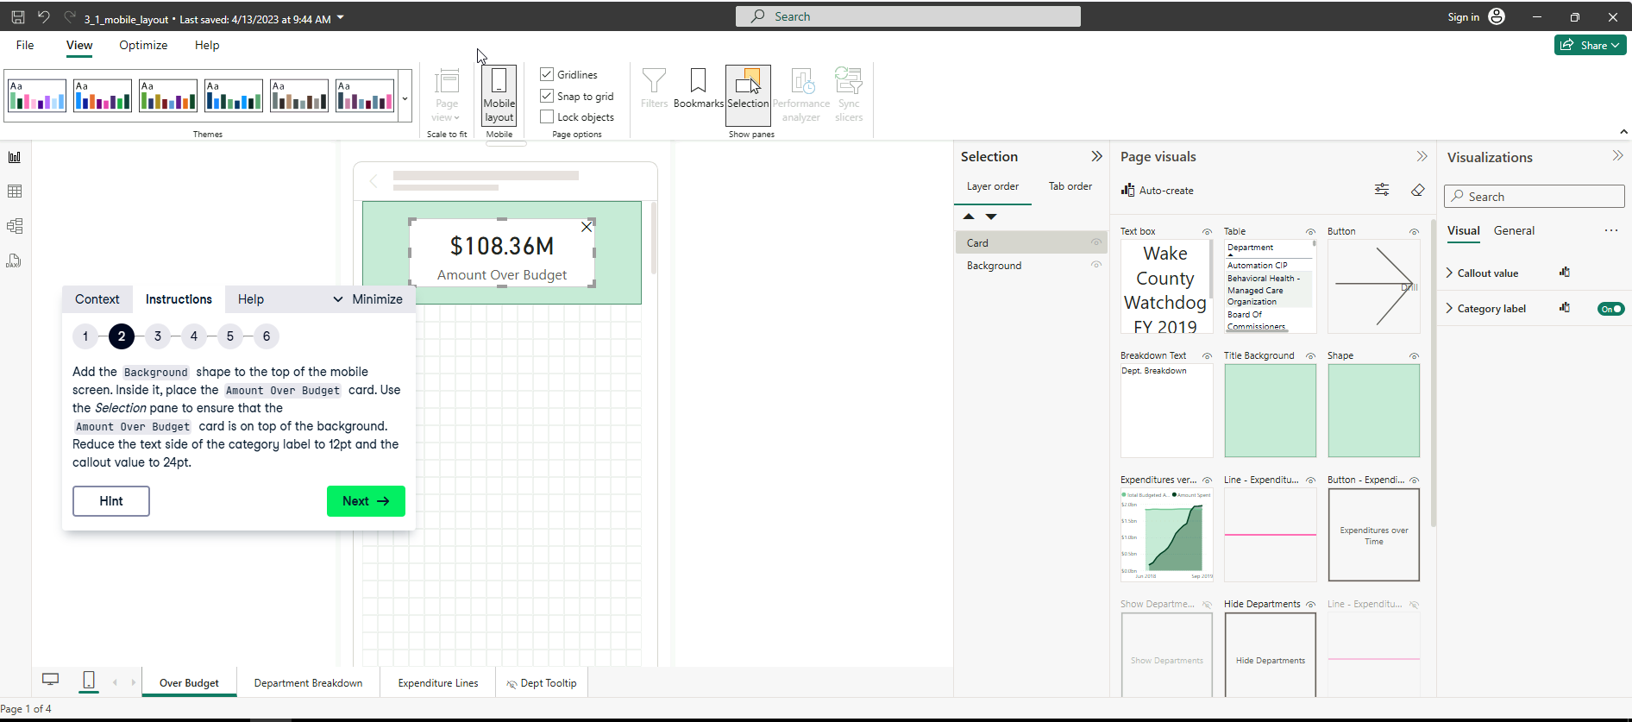

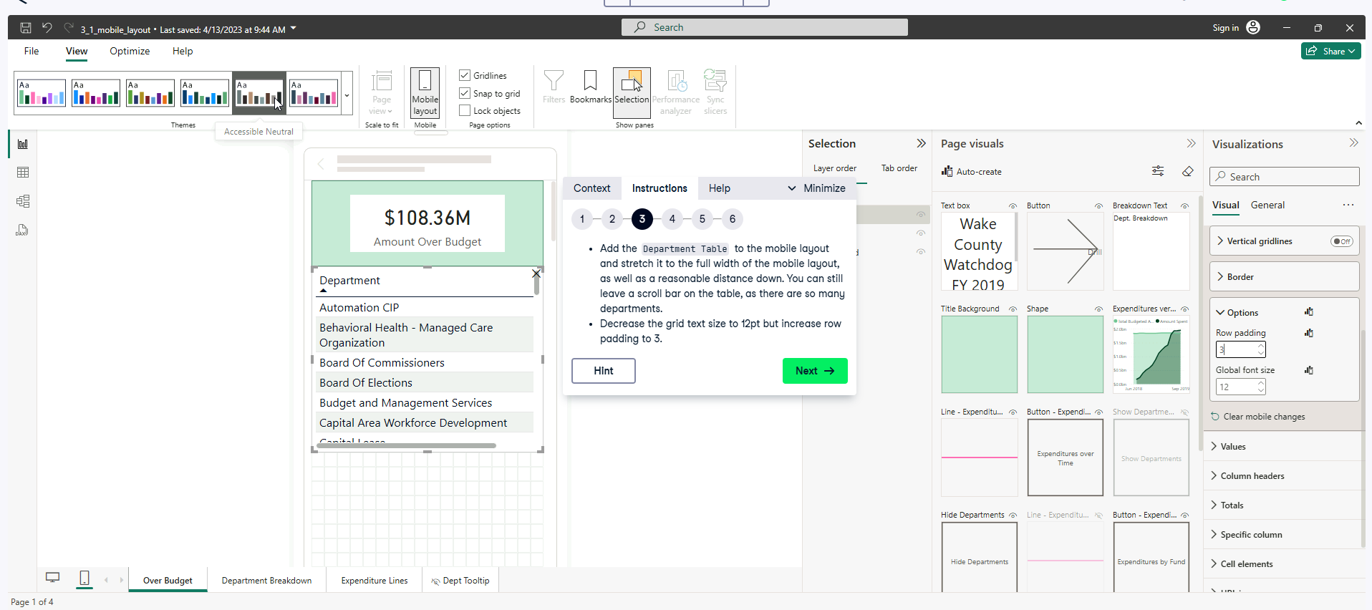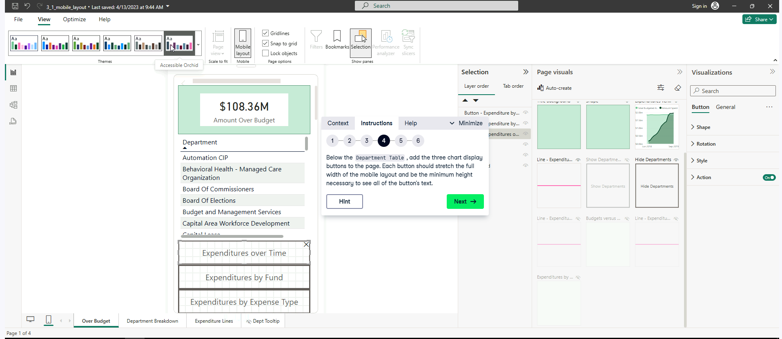

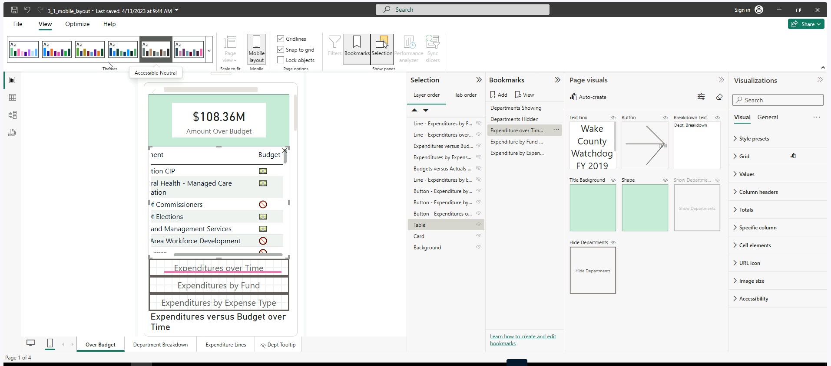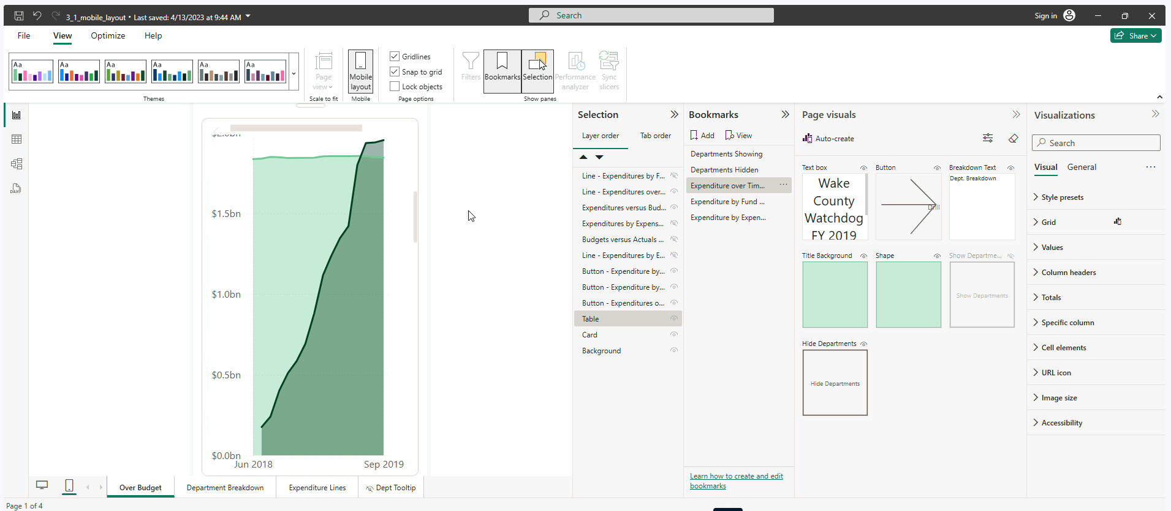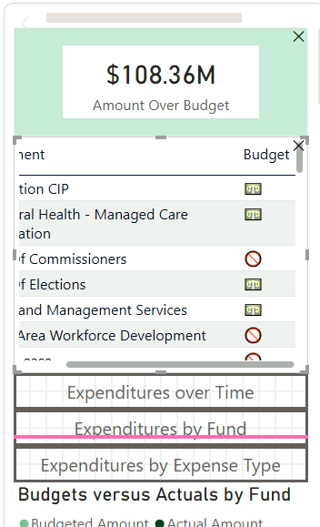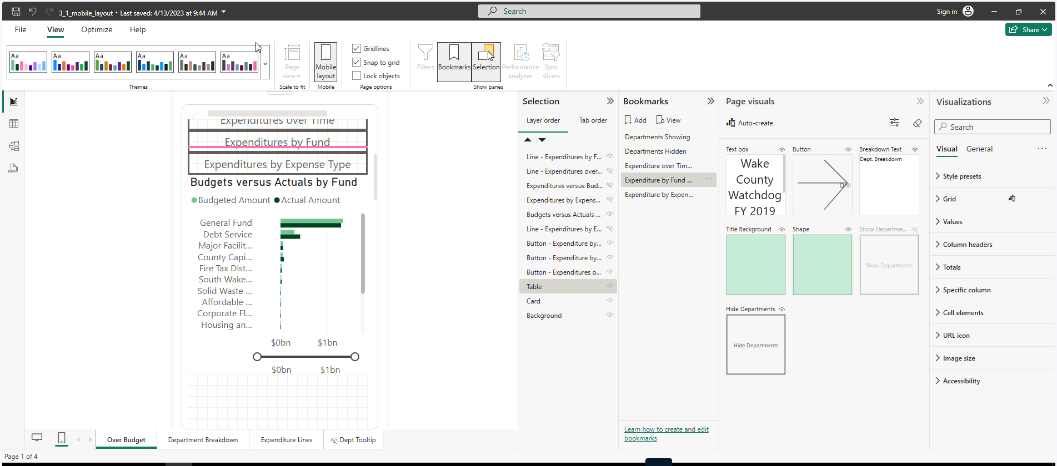

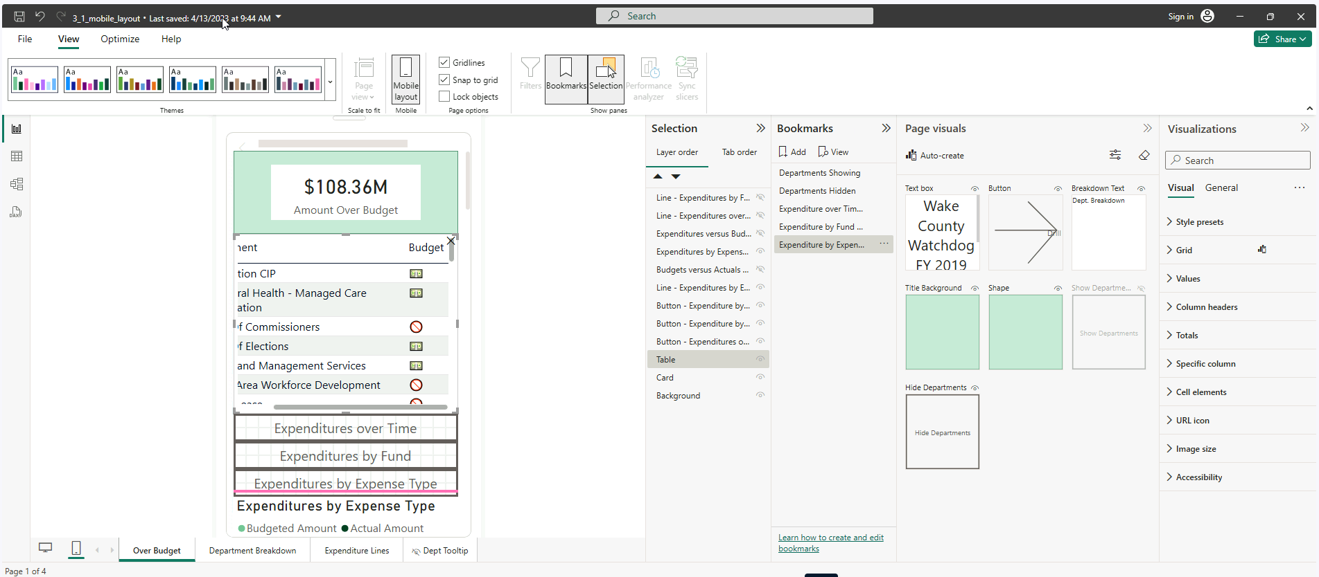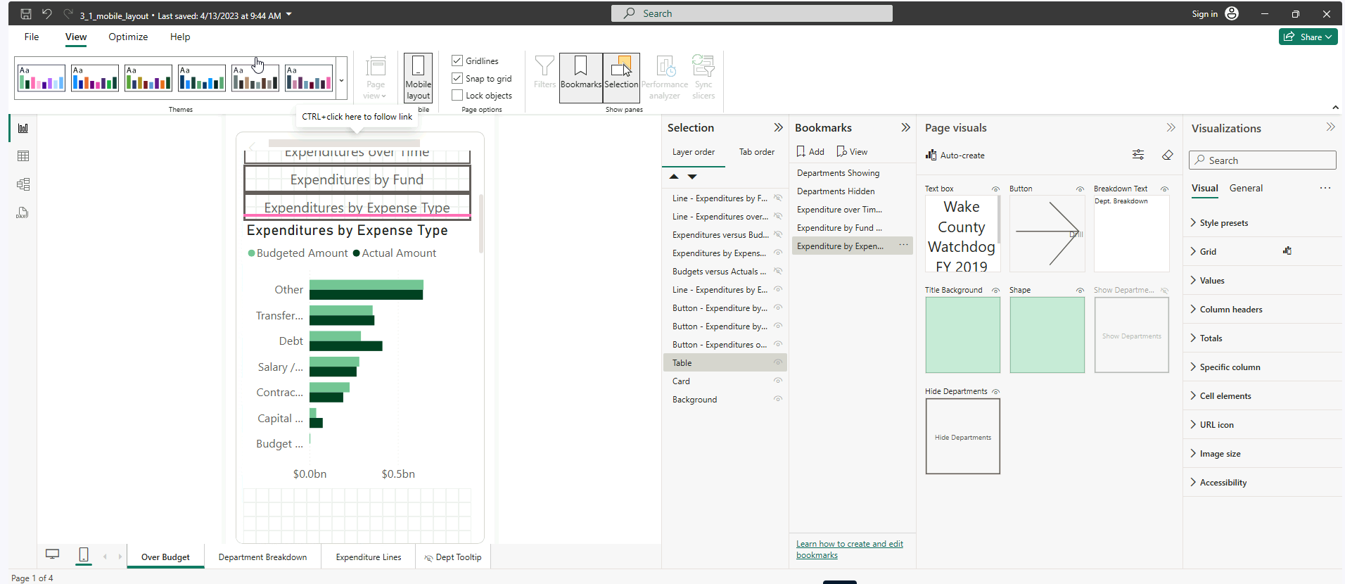

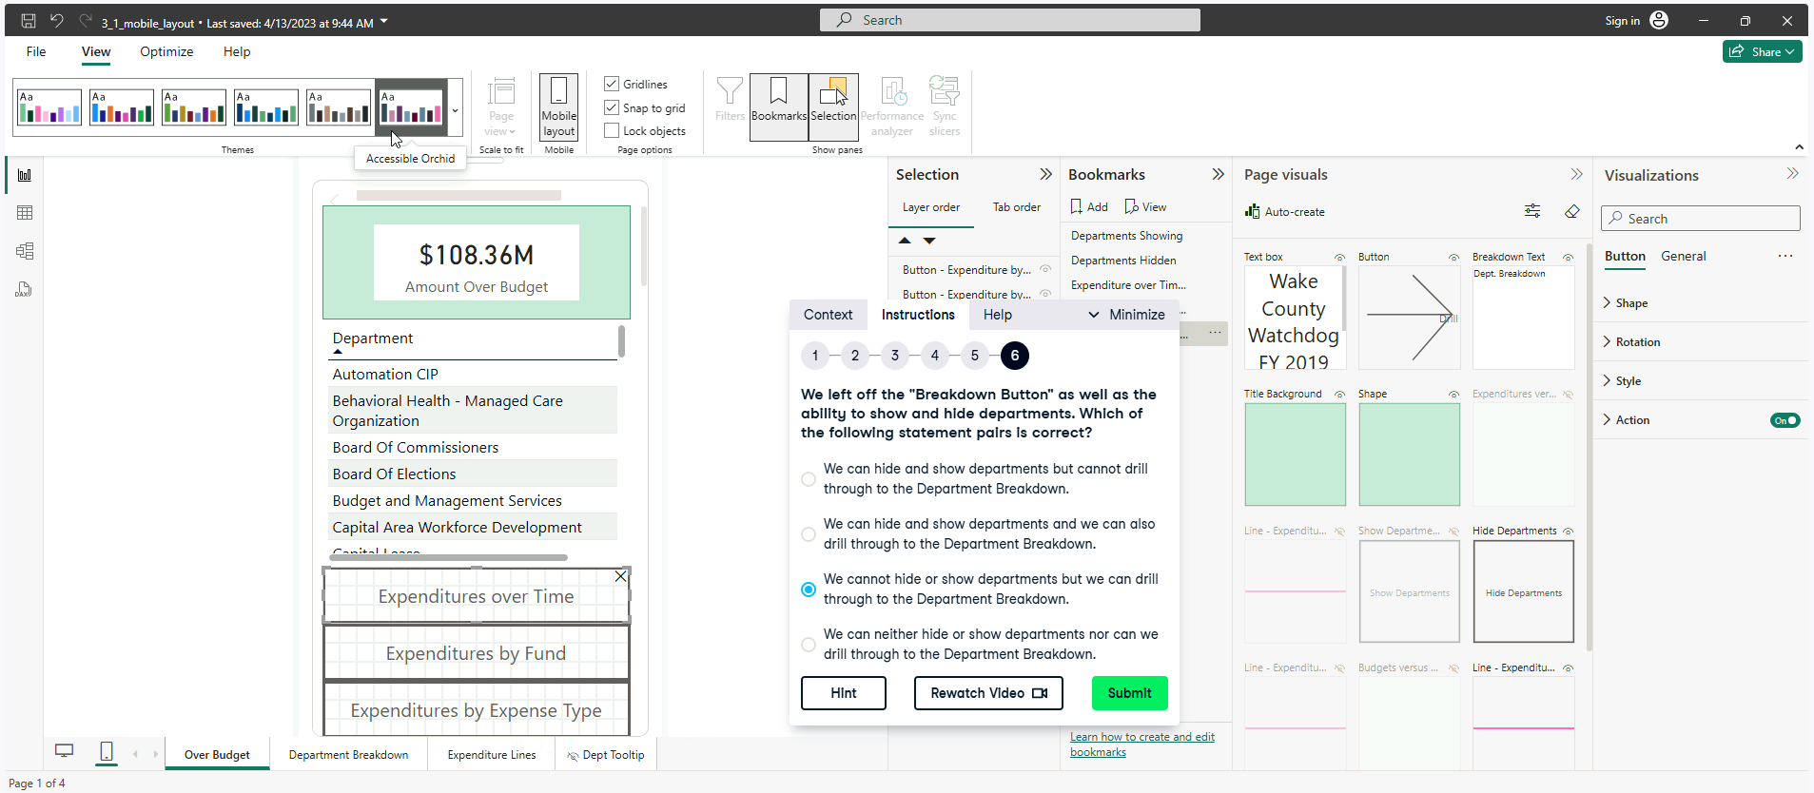

**Exercise 3.3**

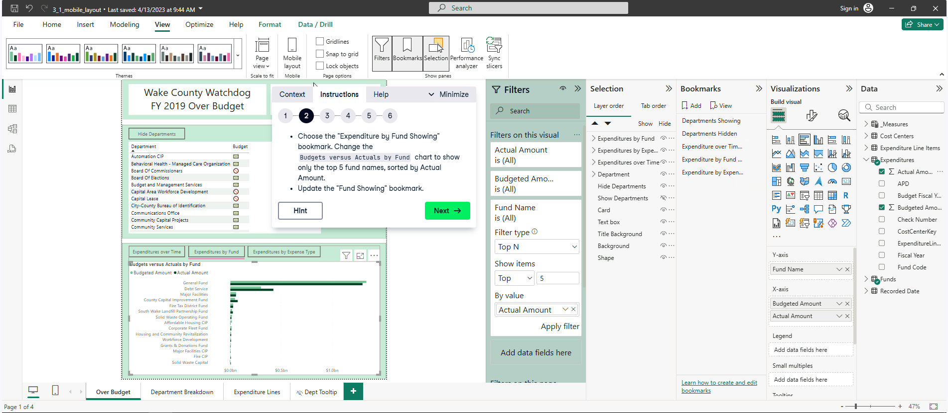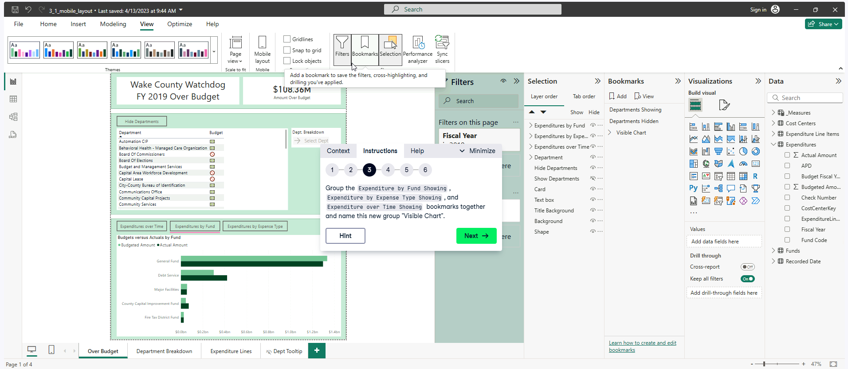

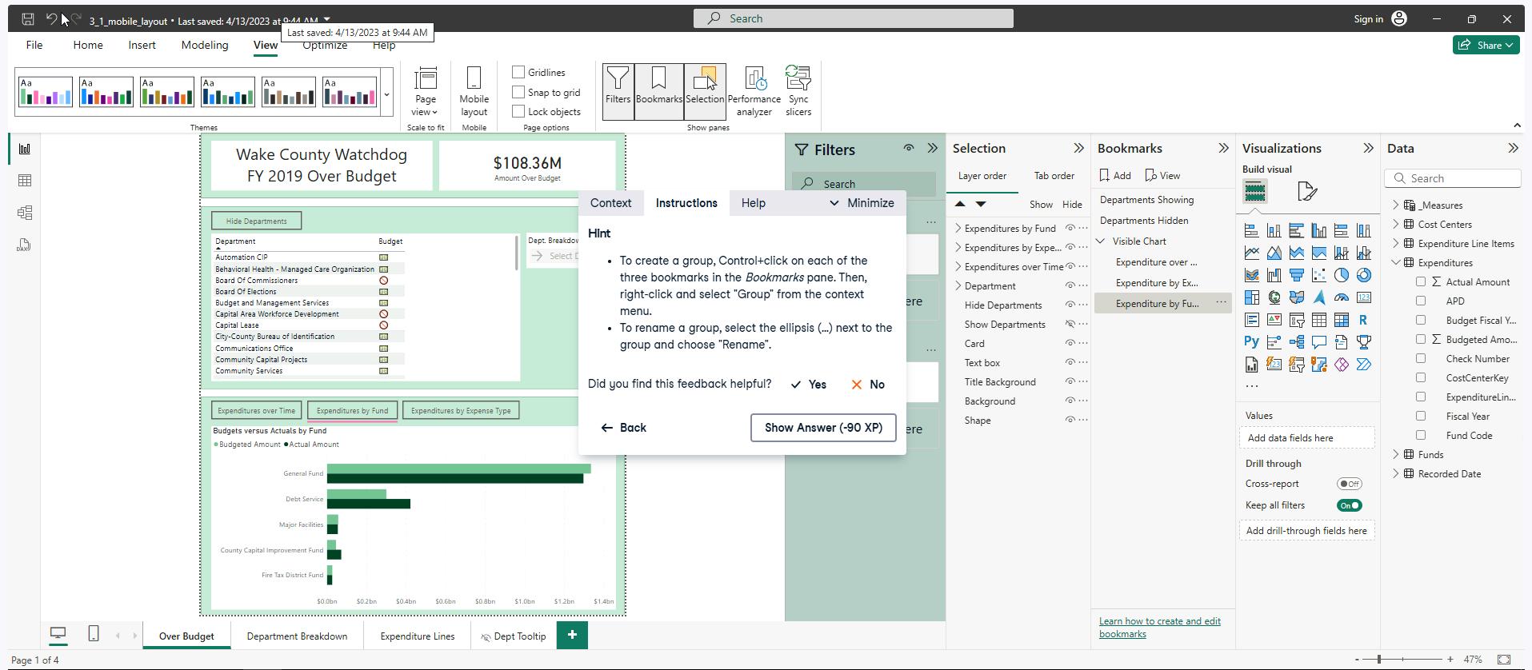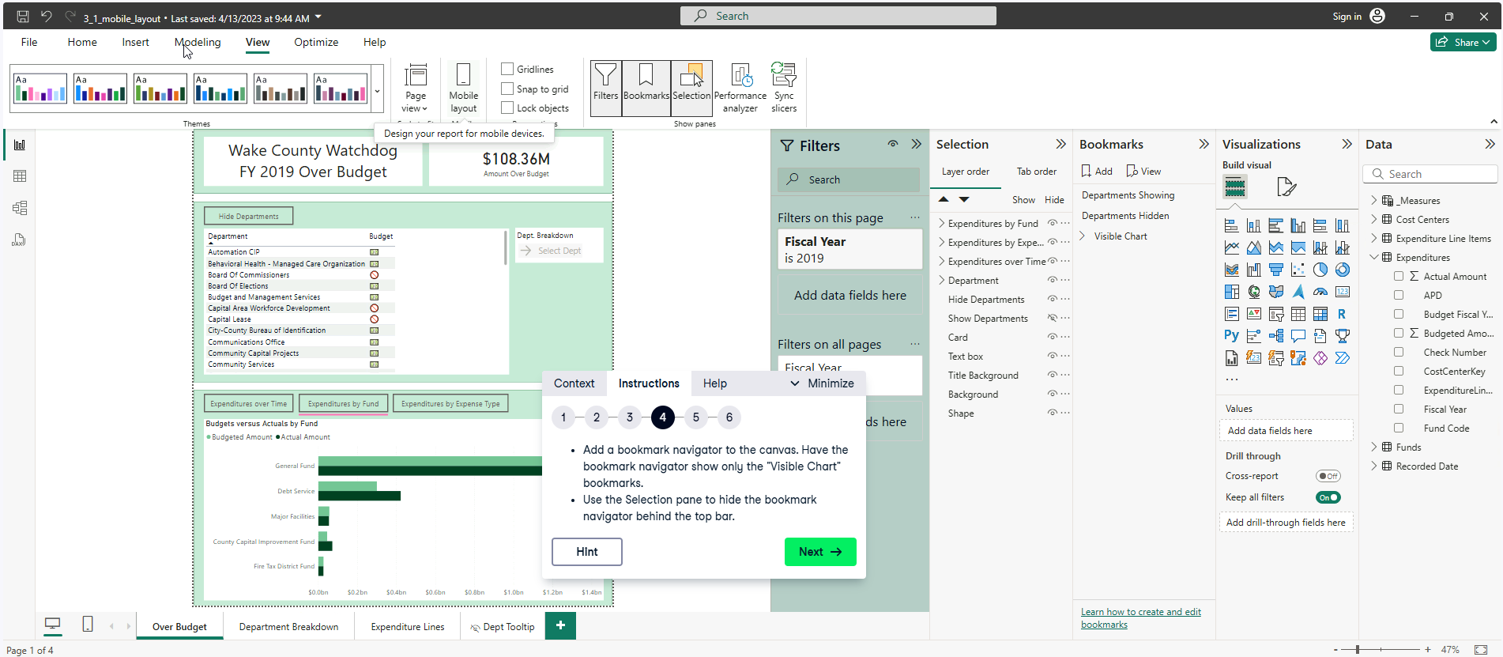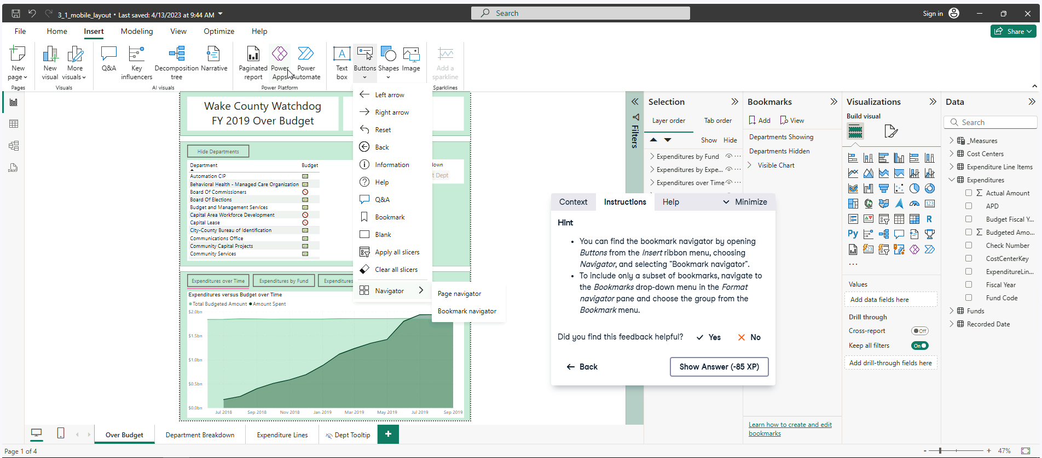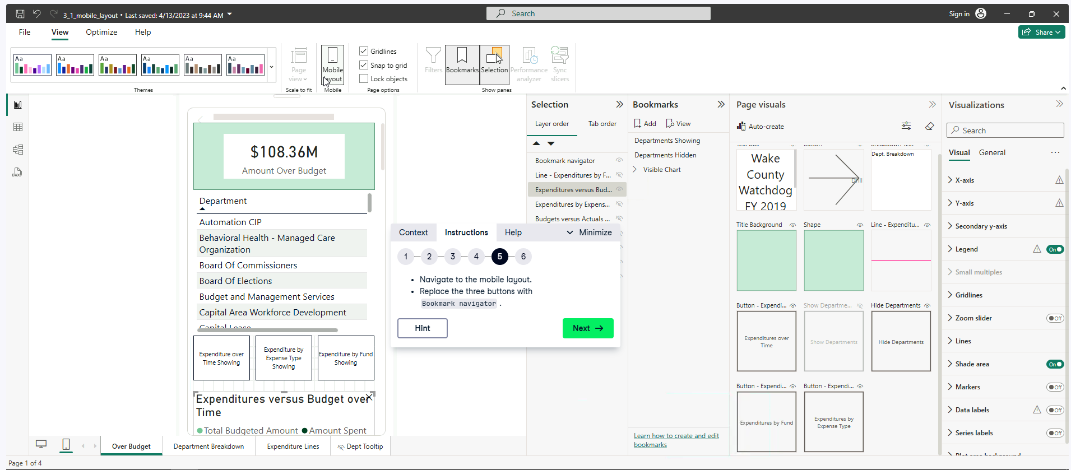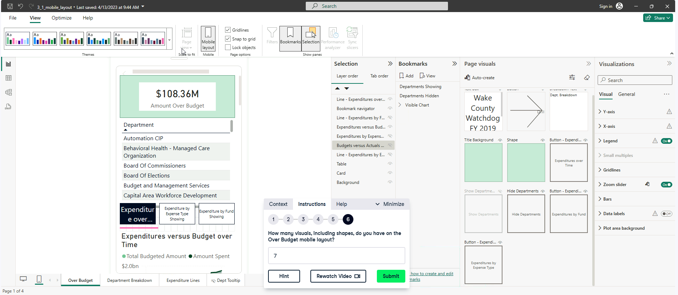

Why?



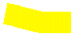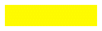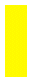

Card, Table, Bookmark Navigation shapes (x3) for each bookmark, Line beneath and Chart.